**THIS QUIZ**

(An online quiz platform)

PROJECT REPORT for

CSE3002-Internet and Web Programming

*Submitted by*

**Divyanshi Thapa -19BCE1367**

**Prakriti Manoj Sharma -19BCE1655**

*To*

**DR. S. JUSTUS**

**BACHELOR OF TECHNOLOGY**

***in***

**COMPUTER SCIENCE AND ENGINEERING**



May 2020

Table of contents

Content

* Abstract
* Introduction
* Requirements
* Design diagrams
* The coding
* Screenshots
* Database schema
* Conclusion

**ABSTRACT**

This project is presented as a J-Component for the subject Internet and web programming CSE3002 under the supervision of Dr S Justus.

* During this pandemic, all of the daily schedules have been made online.
* The schools and colleges were the most hardworking organizations amongst the crisis.
* They have managed to shift the semesters online to prevent the loss of the youth.
* Also, not all schools have access to the resources. Small scale establishments for primary schools and the ones who are denied to the access of online examination servers are facing an issue to assess their students in spite of online commencement of their semesters.
* Design a simple easy to use portal to create online quiz which can be accessed via unique quiz id and can calculate the marks and send the report via email.

**INTRODUCTION**

* Our project will provide a platform to the educational organizations like primary schools, small scale coaching classes to conduct online quiz in a very easy way.
* They just have to create the login and get registered on the portal and then upload the questions and the answer key in a user-friendly interface.
* The registration for creating quiz can be done as the independent creator or as school.
* For the registration of the school, the school id and documents proof will be required and an option of adding members as creator of quiz will be given.
* After submitting all the questions and setting the answer key, our platform will create a webpage containing all the questions and options in a proper quiz format and will also generate a unique id of that webpage containing quiz.
* This webpage will also display the marks after completing the quiz.
* The marks and the responses will be sent to the registered email of the student to view the answers and answer key.

Requirements

END POINTS:

1. Home
2. Home\Sign in for school
3. Home\ Signup for school
4. Home\Sign in for school(Choosing a school)\Choose the class and subject
5. Home\Sign in for school(Choosing a school)\Choose the class and subject\upload the question and answer key
6. Home\Sign in for school(Choosing a school)\Choose the class and subject\upload the question and answer key\ generate a shareable link for students to attempt quiz

7. Home\ Signup for school\ Enter the school’s board and then serial number.

Home page

Two separate options for existing school to sign in and new school to sign up.

Sign Up

First choose the board of the school and then enter the school’s serial number. Enter all the details like full address of the school, principal’s name and telephone number. An account of the school will be created and a password with user name will be provided.

Sign in

First select the school from the drop-down box. Then enter the school’s user id and password. Then enter your mail id (mail id of the teacher). Now a page will be displayed where the teacher will have to choose the class and subject. Now it will be directed to anew page where there will be an uploading mechanism (Enter the question and the answer key).

An online webpage will be created containing that questions and options and a shareable link will be created so that the teacher can share the link to the students so that they can attempt quiz. As soon as the quiz page is created, a mail will be sent to the school admin block to keep a track record of the quizzes that are created.

This project requires a moderate to advanced knowledge of HTML5, CSS, JS, PHP. And wamp server database(phpmyadmin) is used for database management.

**Design Diagrams**

**Class diagram**

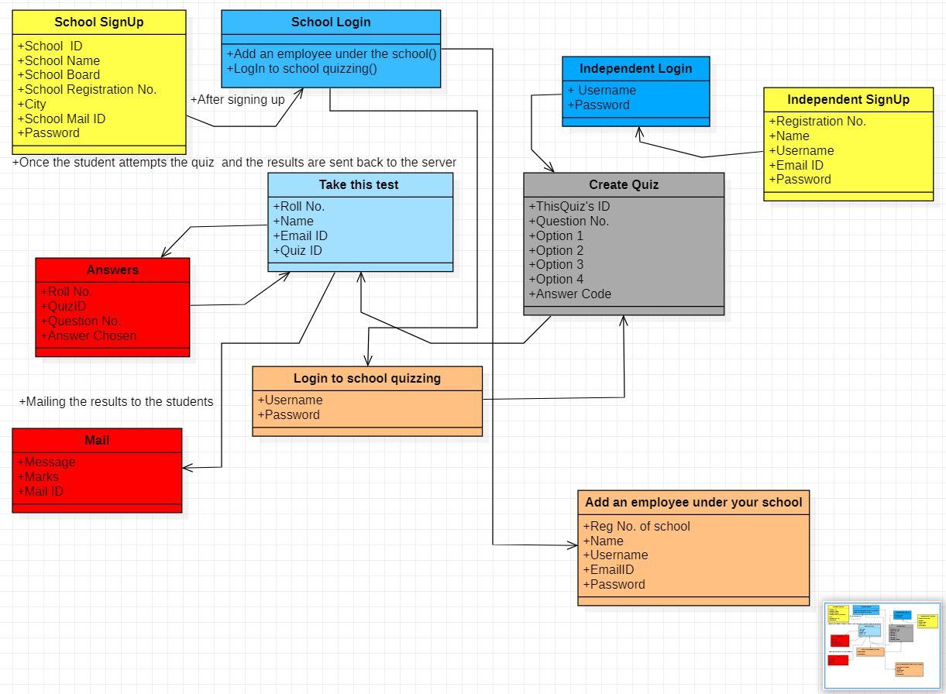

**Sequence Diagram**

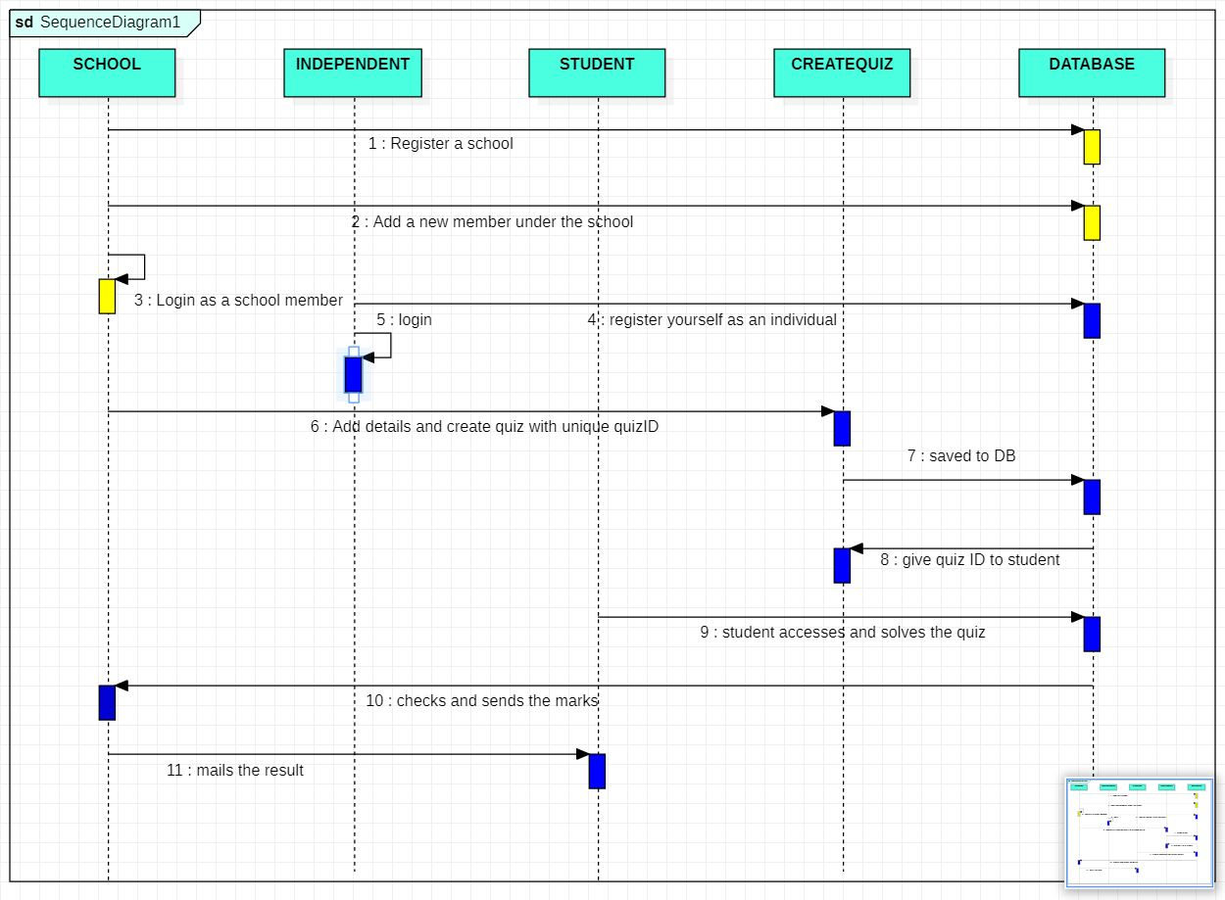

**Activity Diagram**

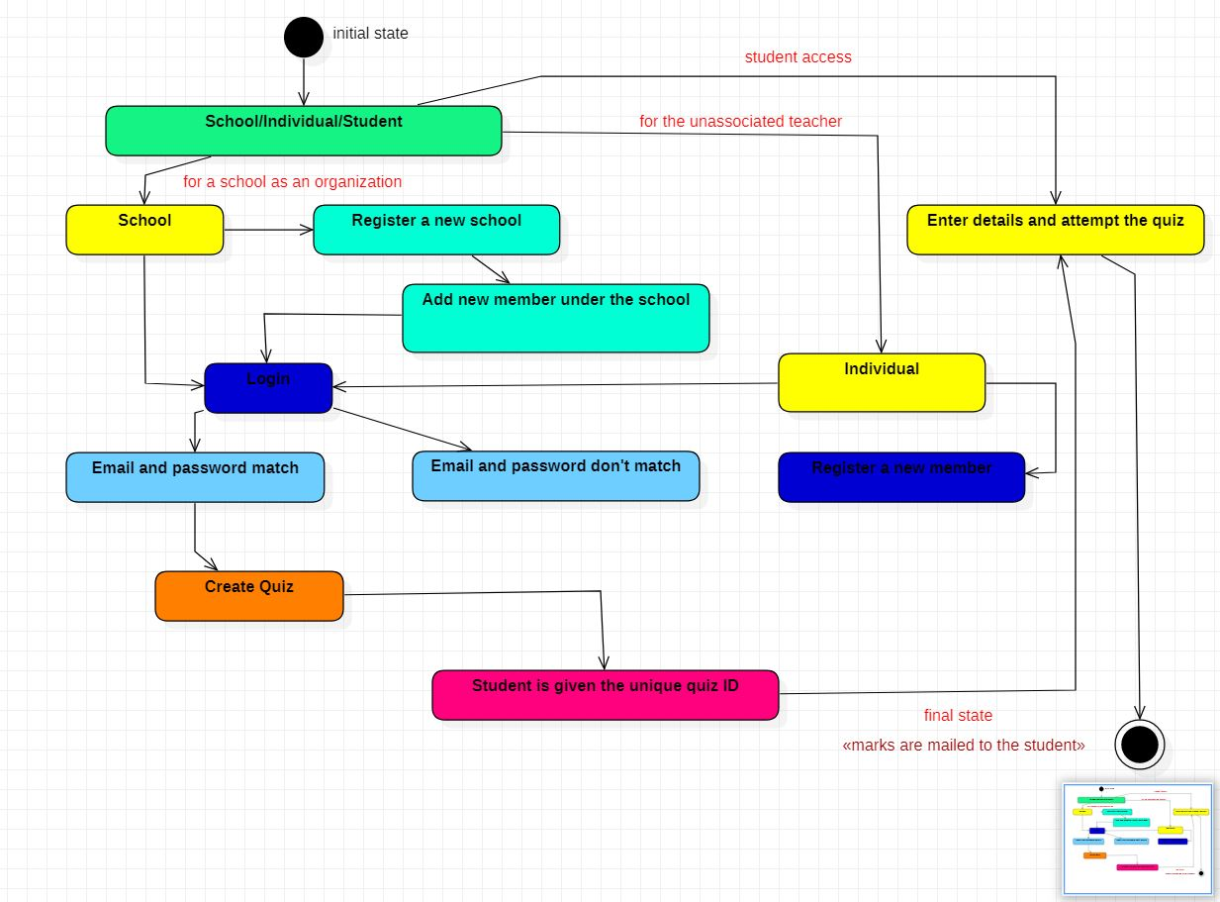

**Data Flow Diagram**

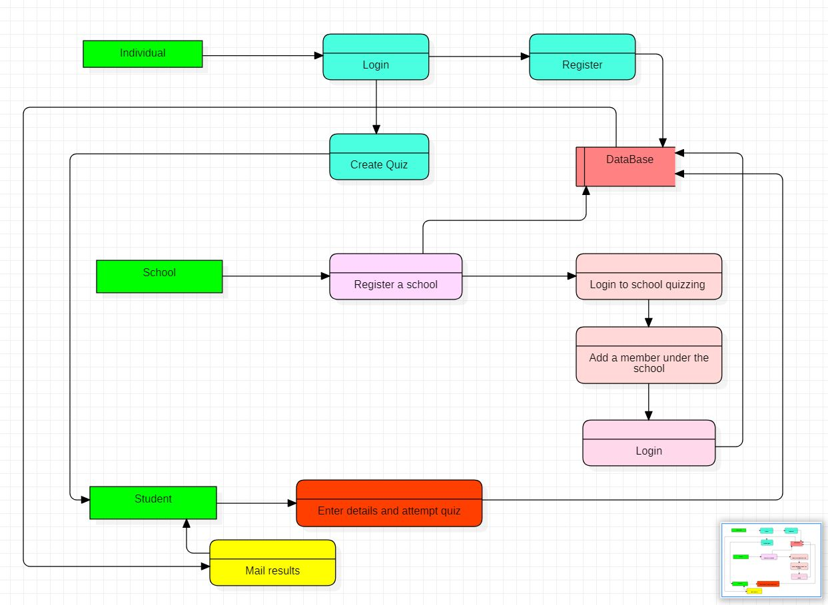

**The Coding**

Index.php

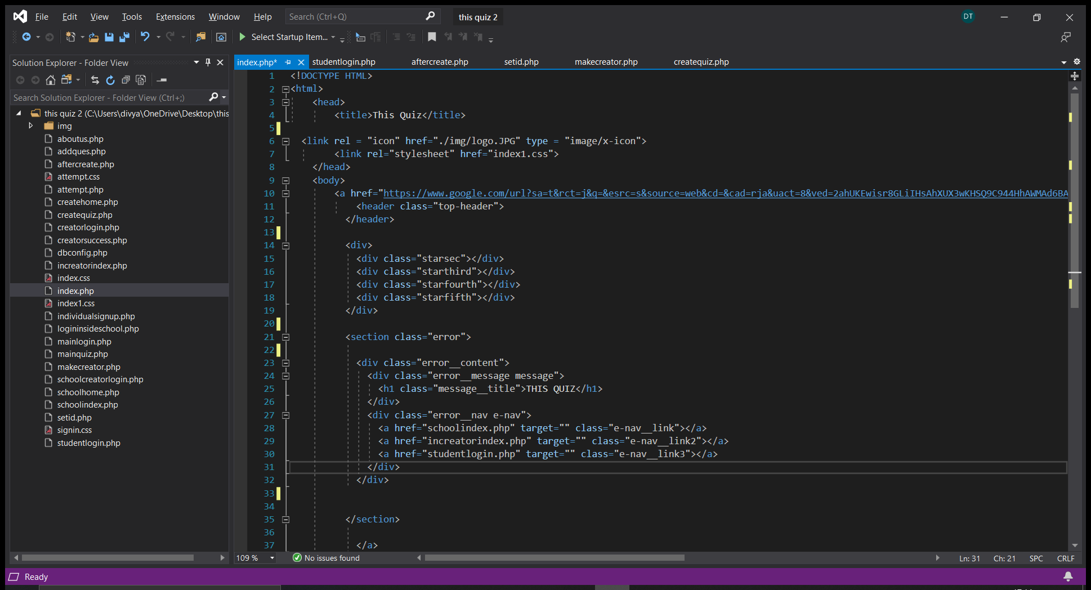

Add member (makecreator.php)

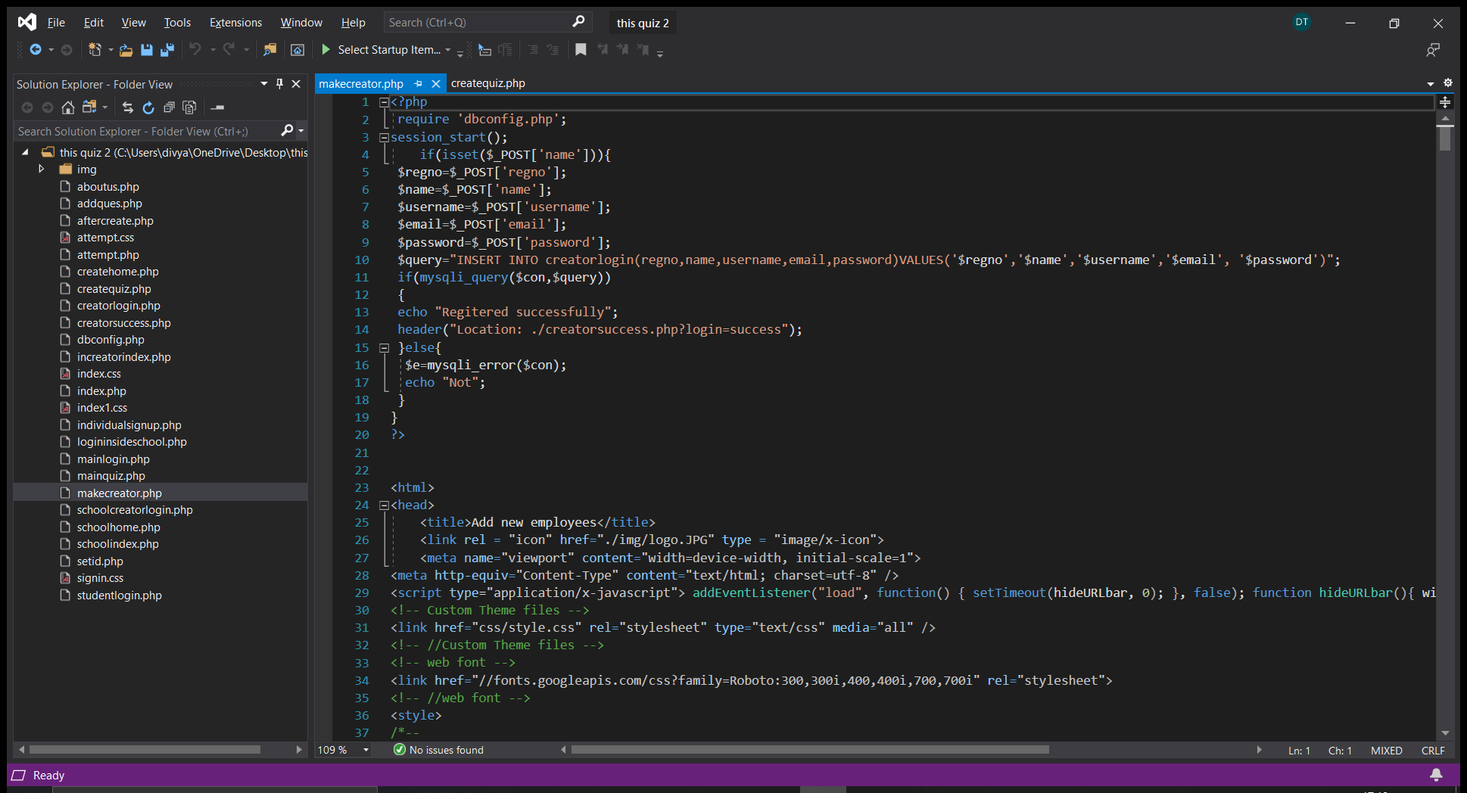

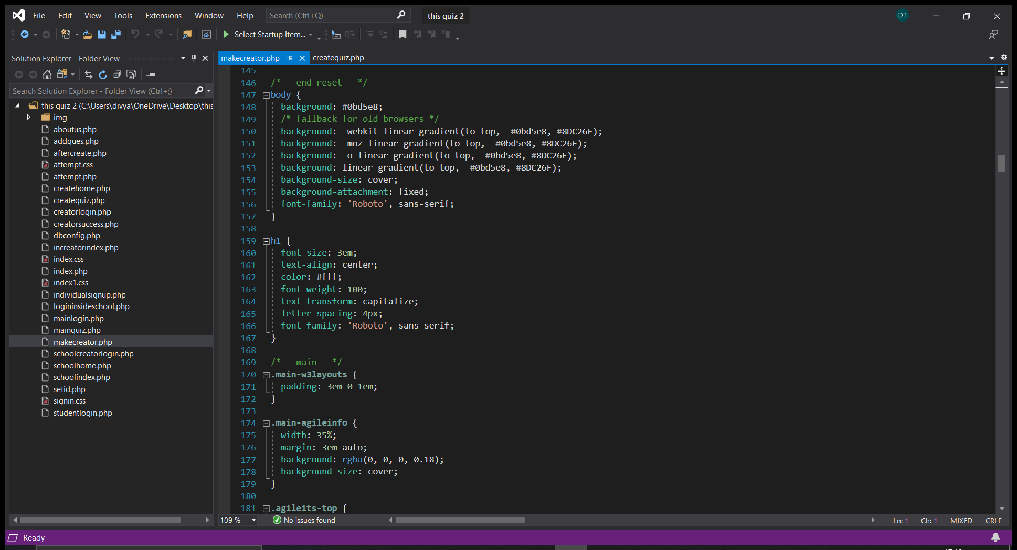

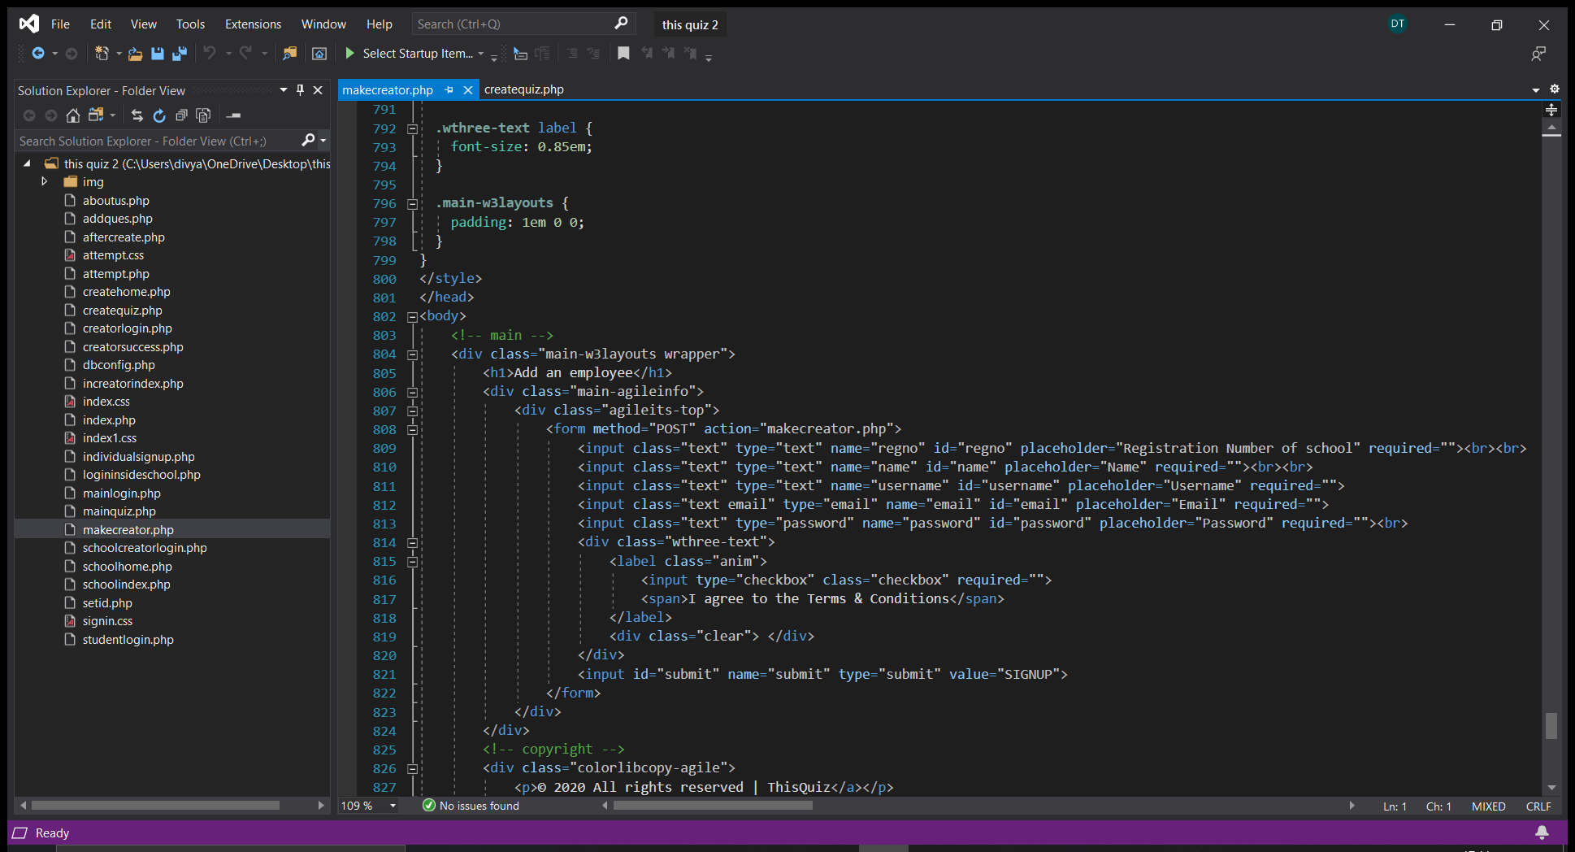

Set the Unique Quiz id (setid.php)

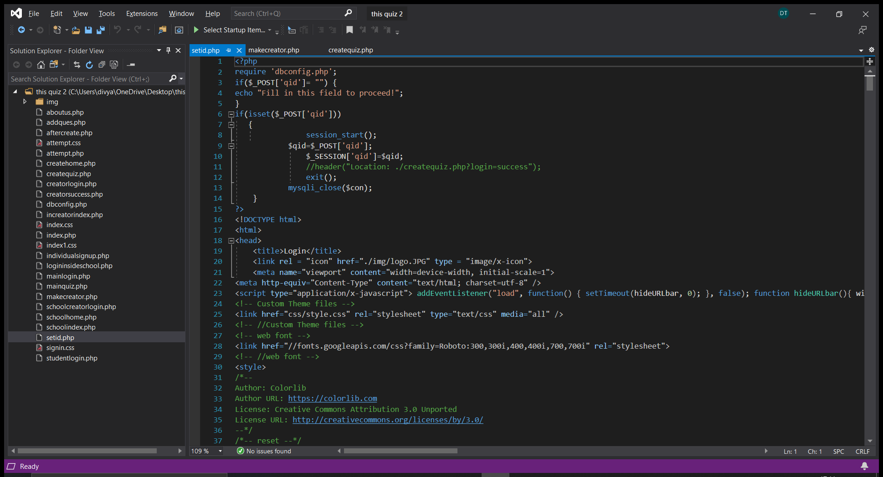

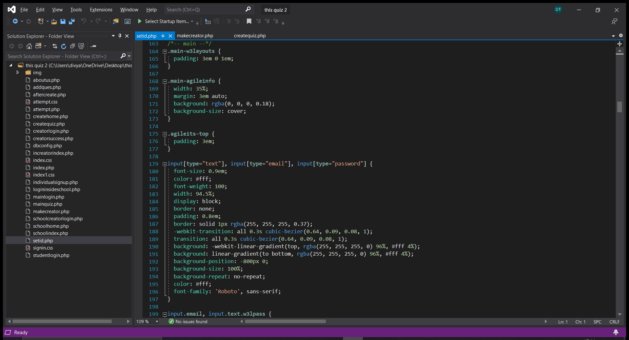

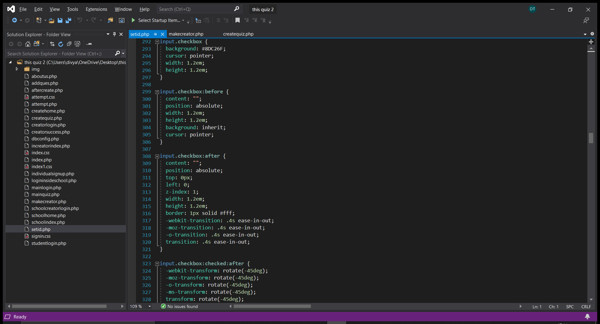

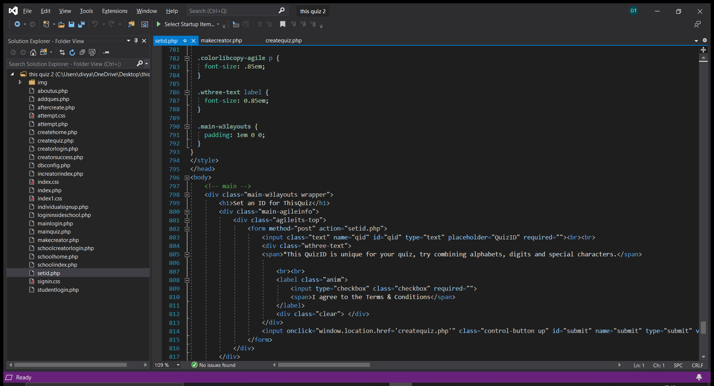

Creation of Quiz(Createquiz.php)

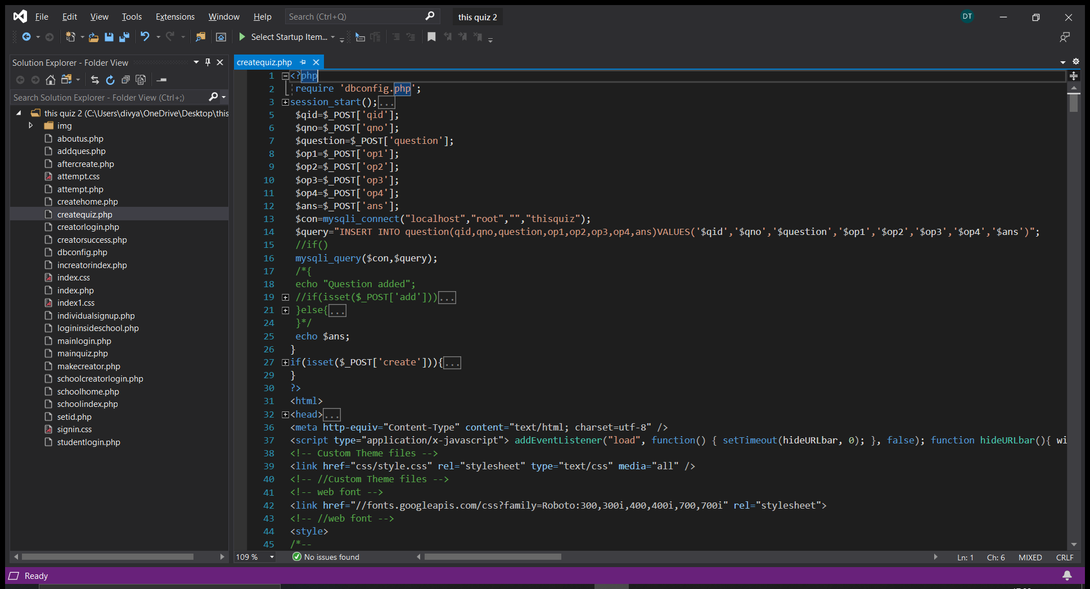

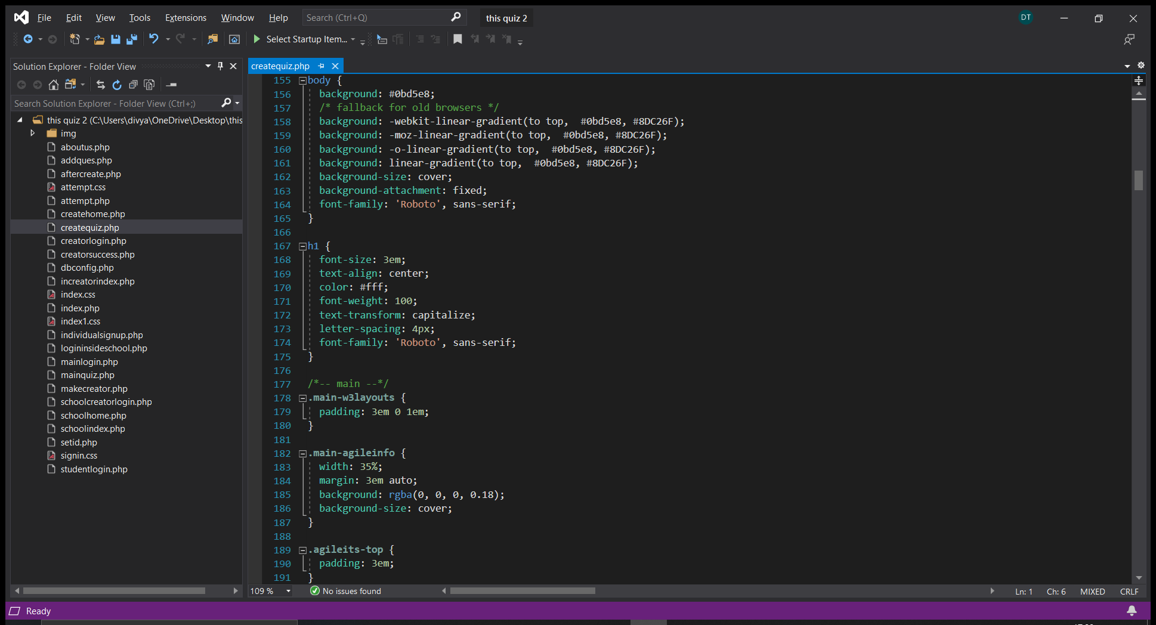

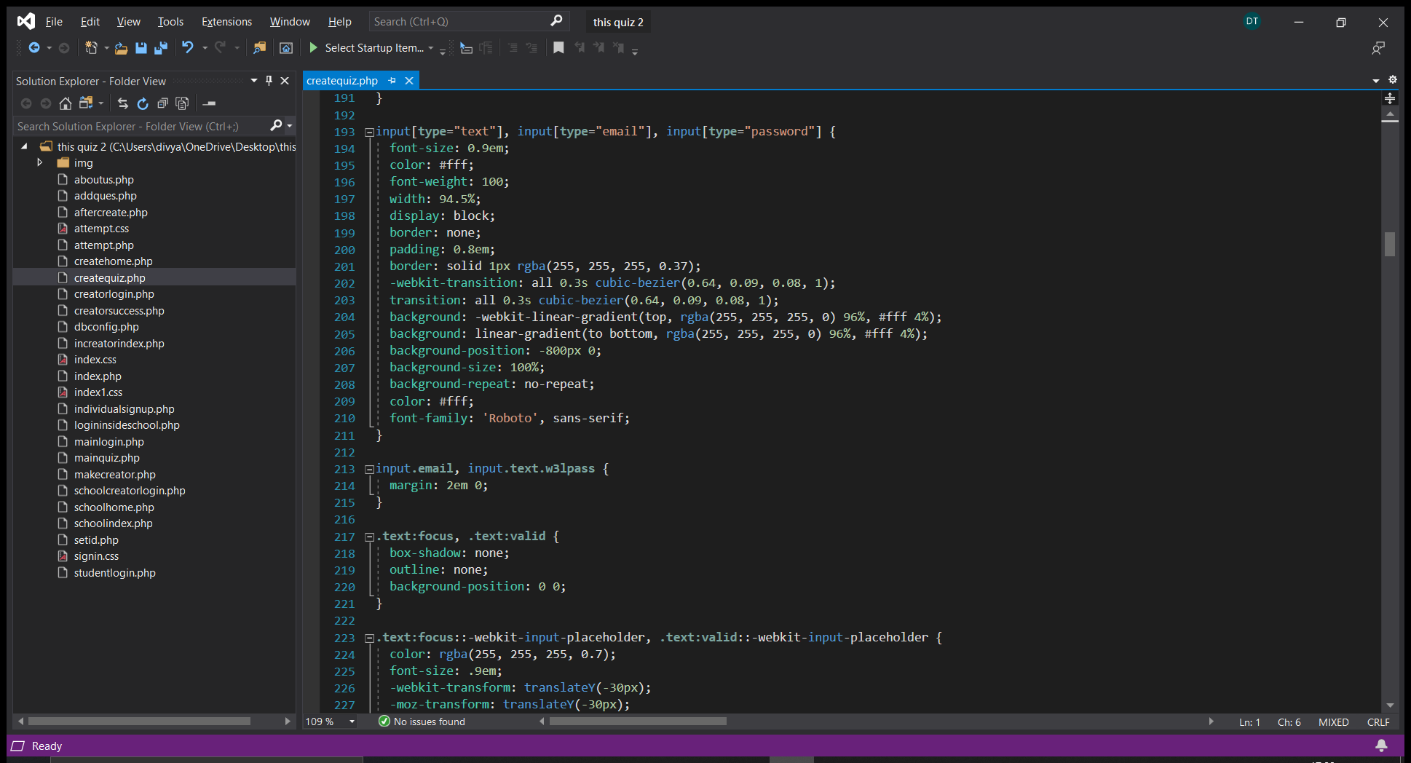

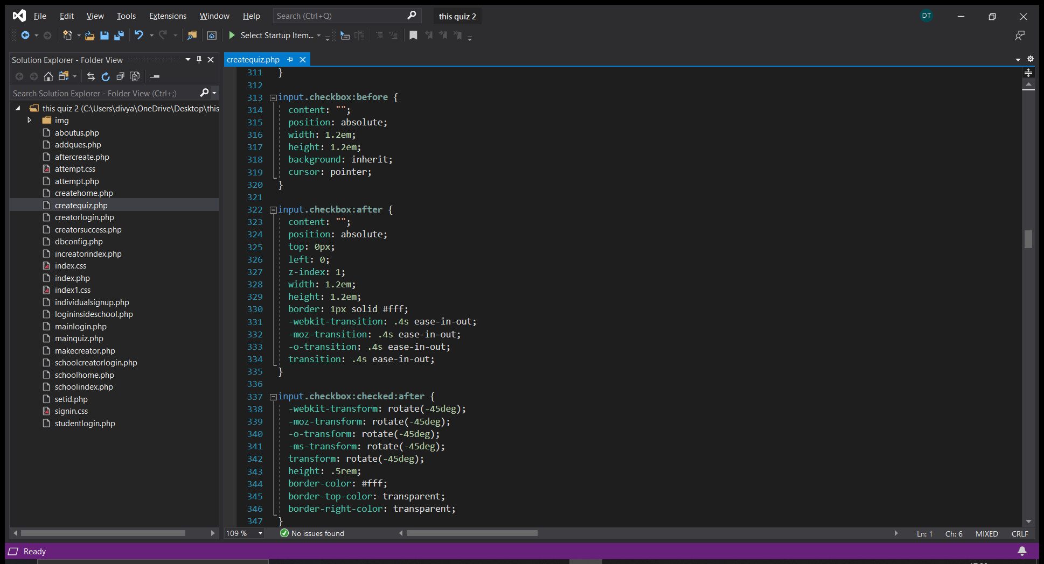

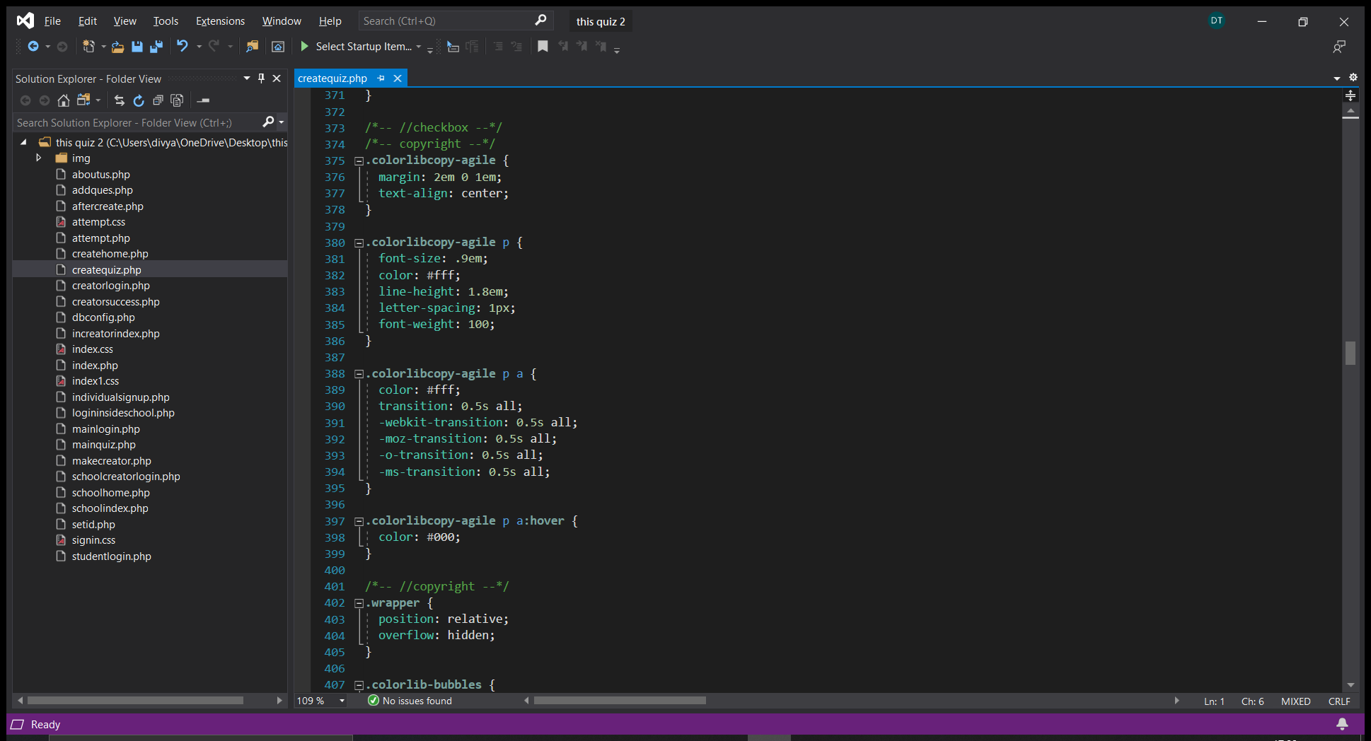

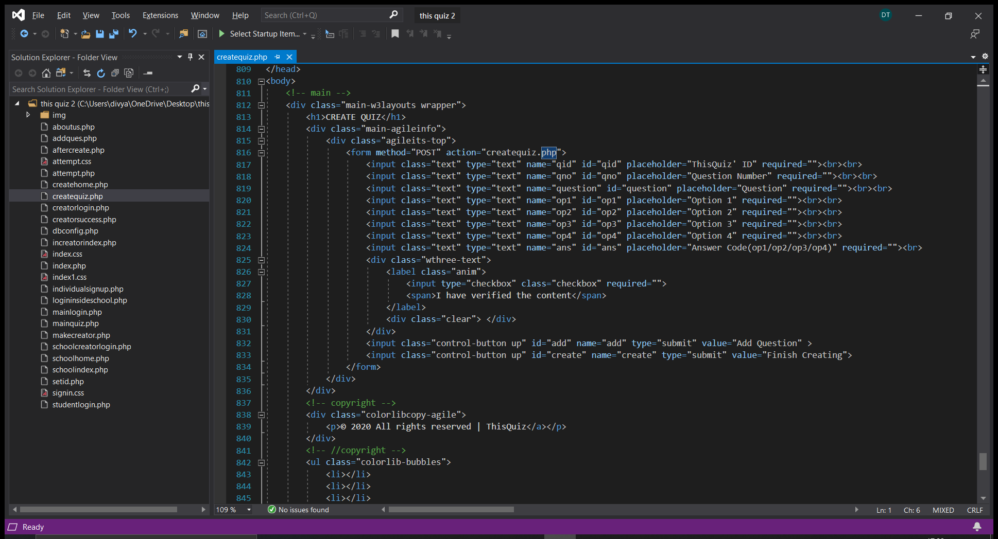

Attempt Quiz(attempt.php)

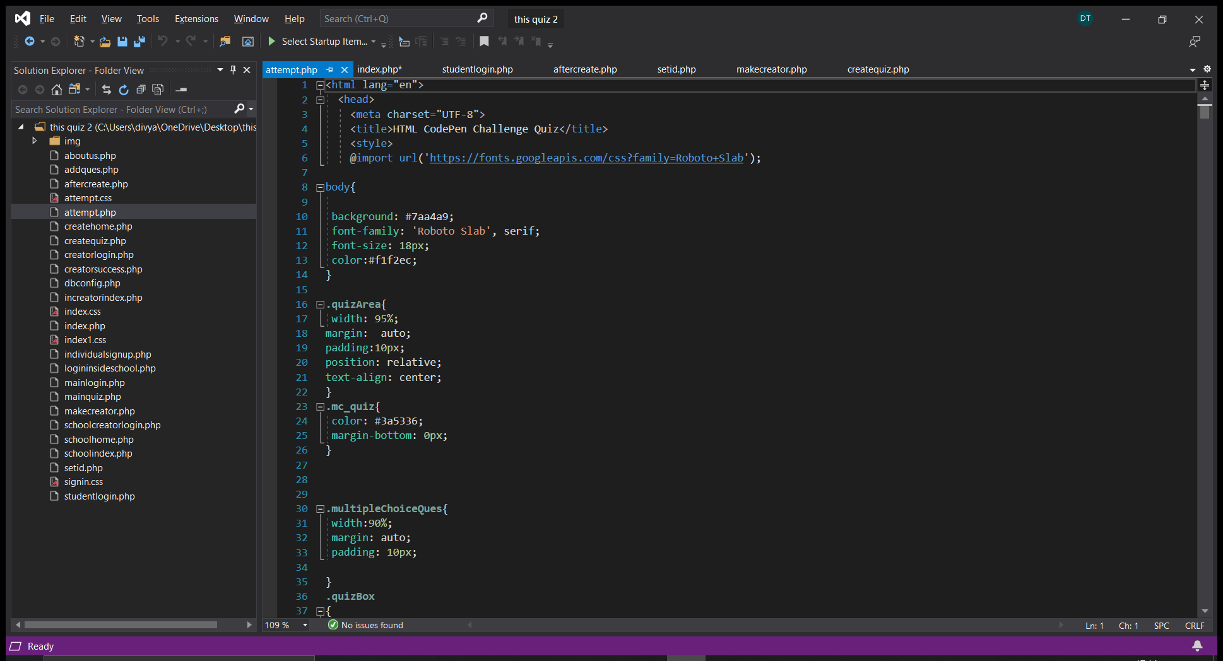

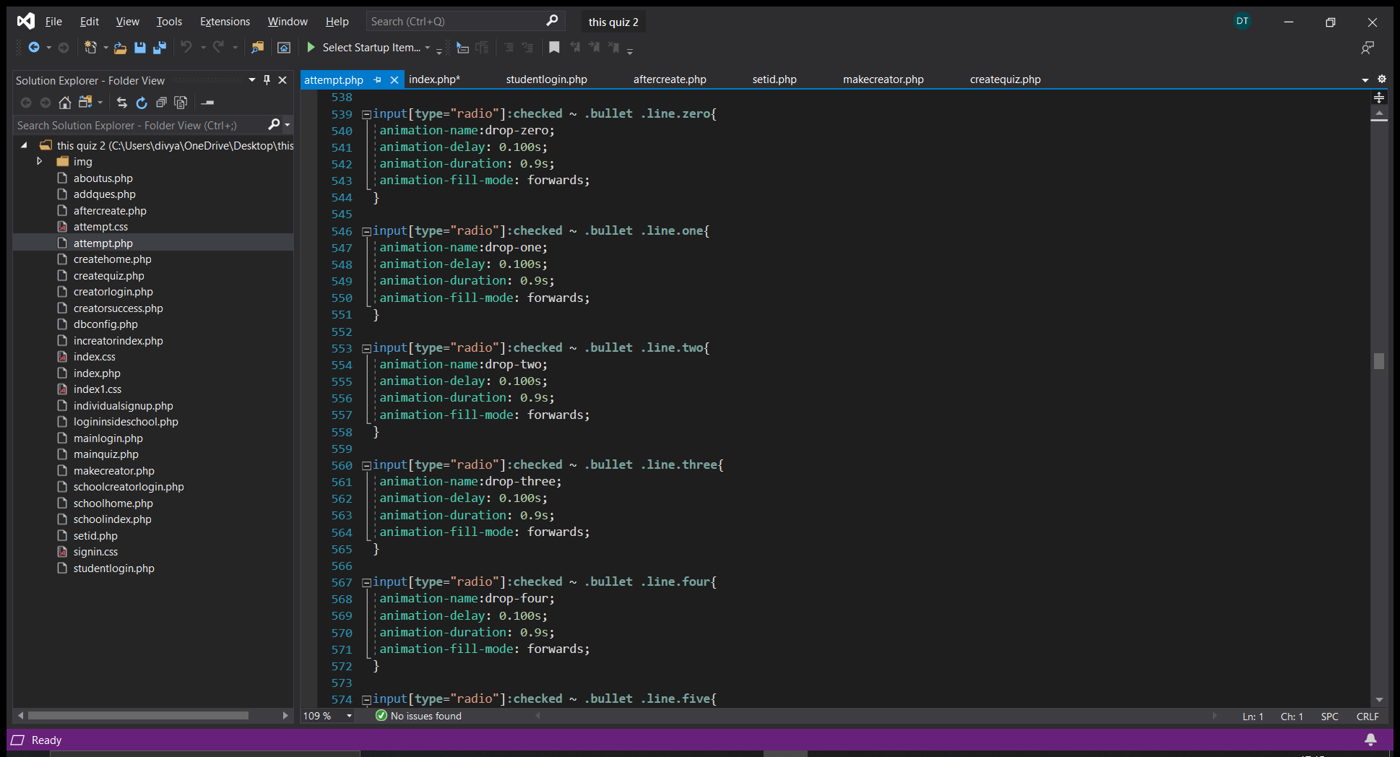

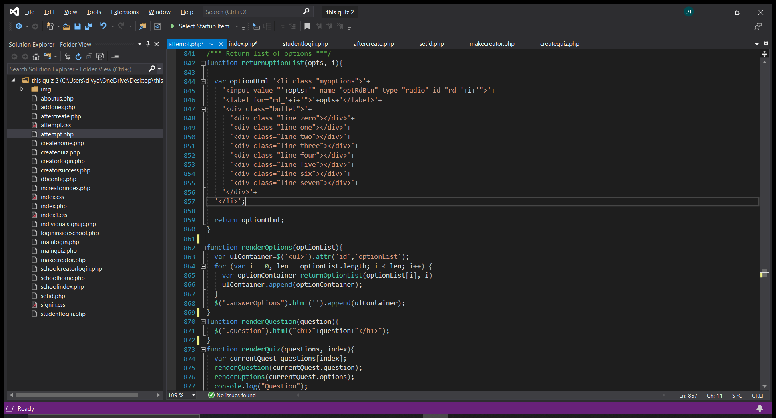

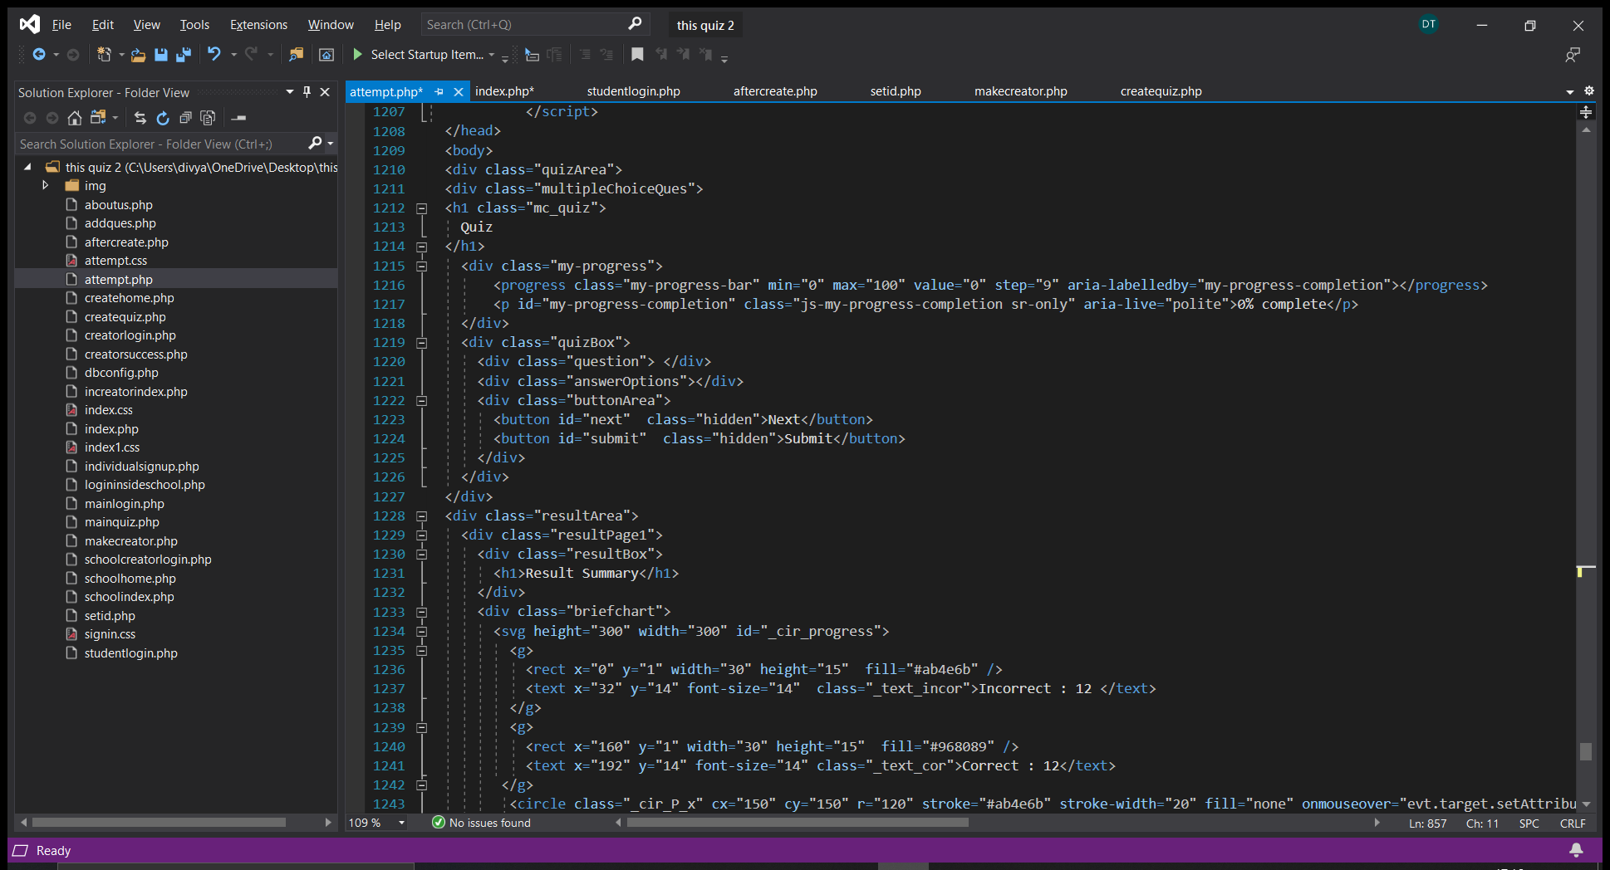

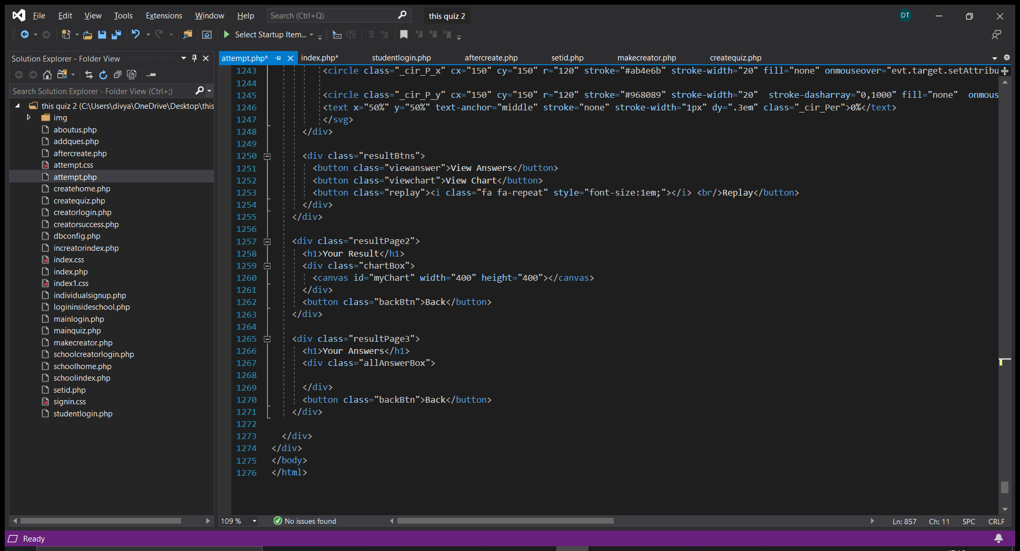

SCREENSHOTS:

HOME PAGE



It directs the user to 3 different platforms i.e School, Independent and for the student(to take the test).

PROCEEDING TO THE SCHOOL’S SIDE FIRST :

It leads to two options.



Here the login page leads further to the other two.



Add an employee to the school leads to

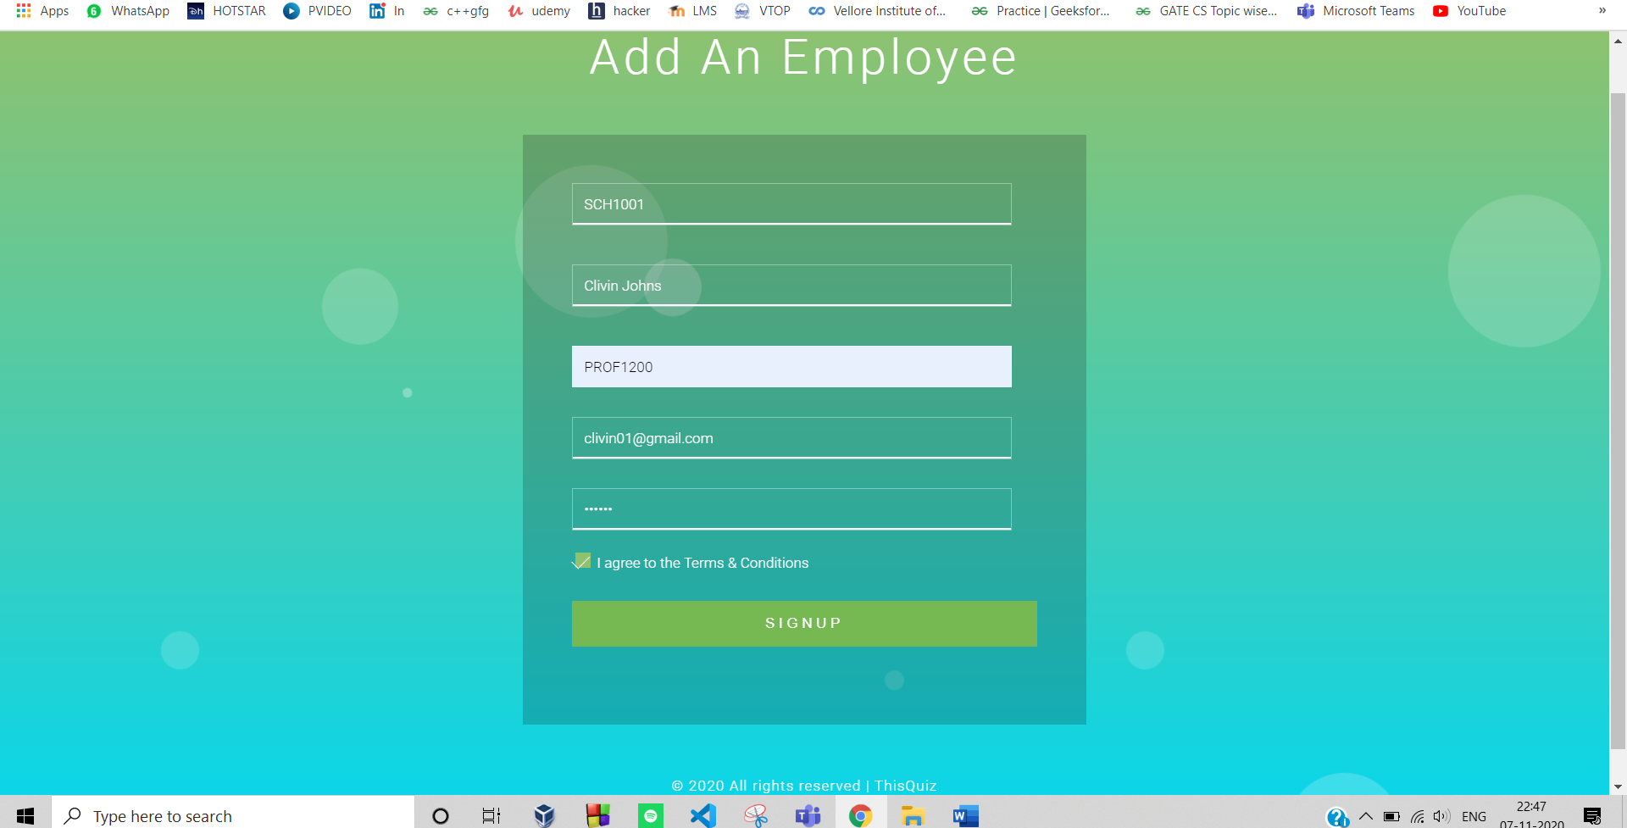

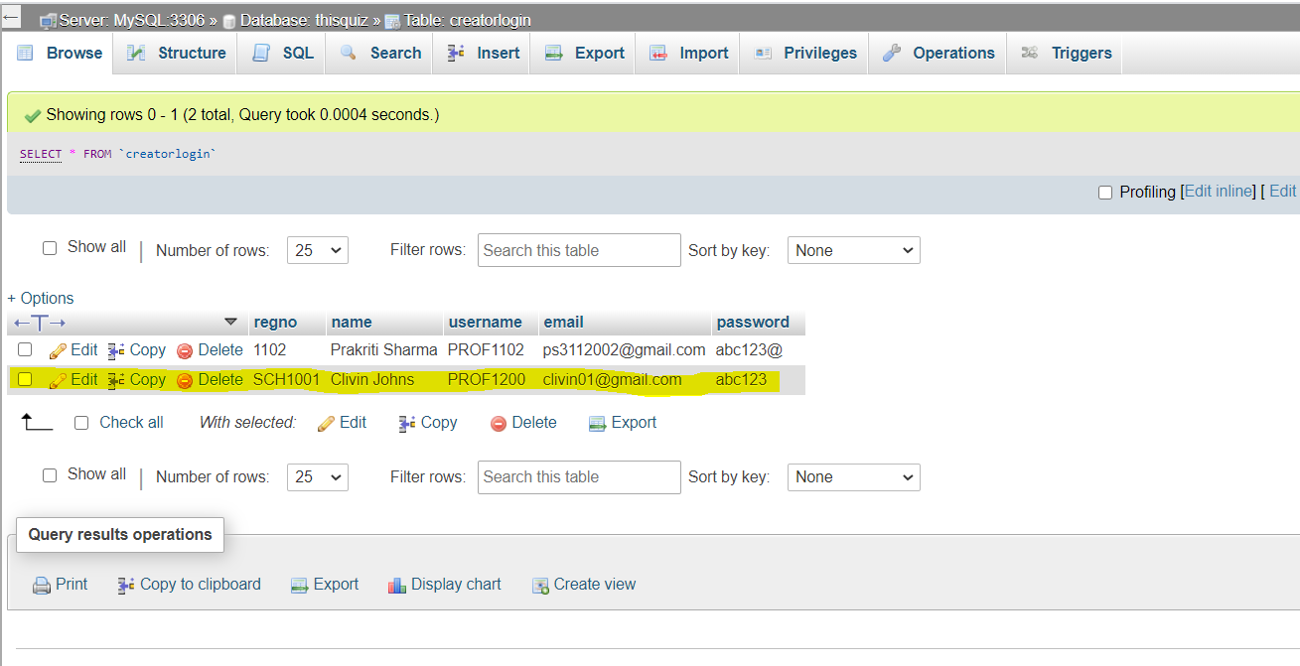

After pressing the signup button the data get stored into the sql data base.



Log In to the school quizzing brings you the option of creating quiz or your students.

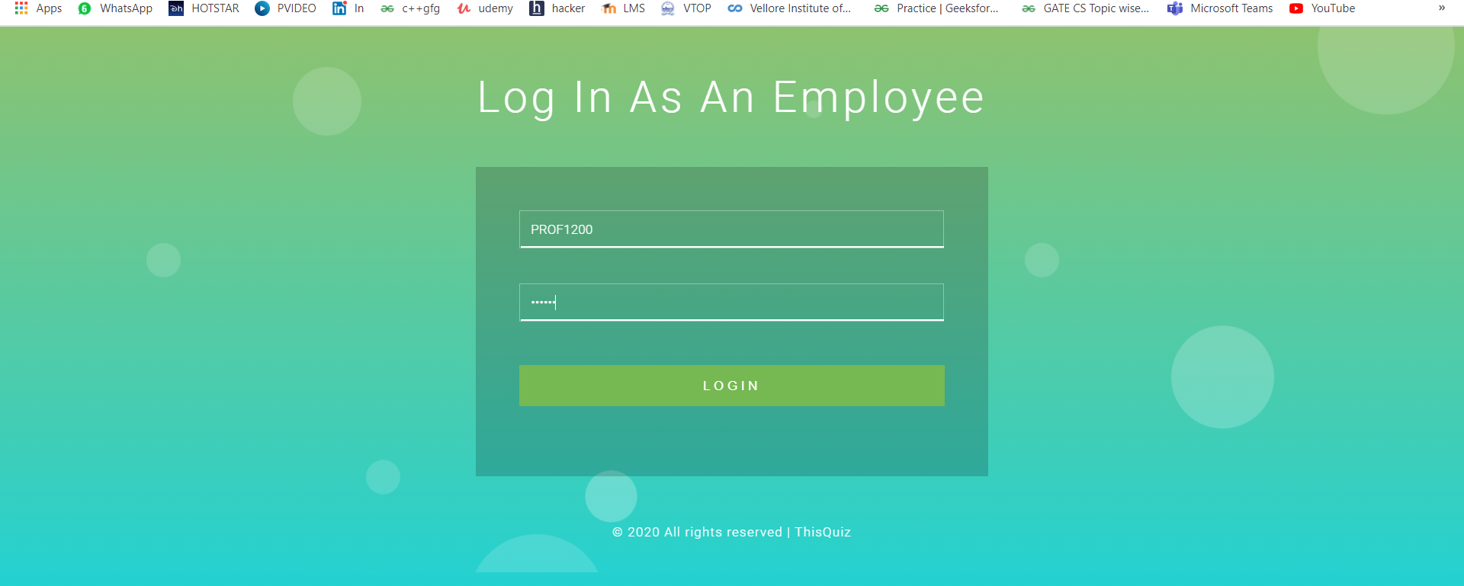

Logging in with correct credentials brings you the create quiz page.

And if the login credentials are incorrect it brings you this page:

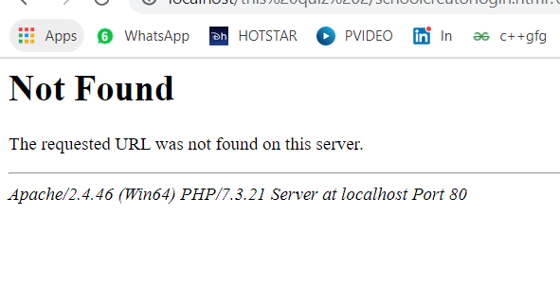

The quiz creation is done through this page

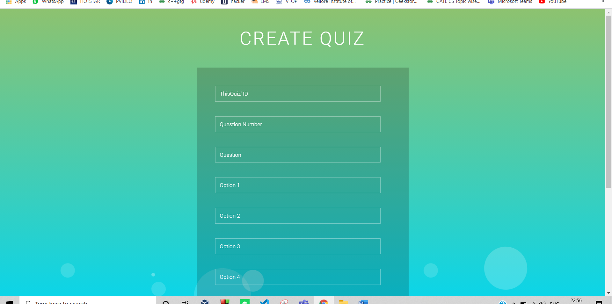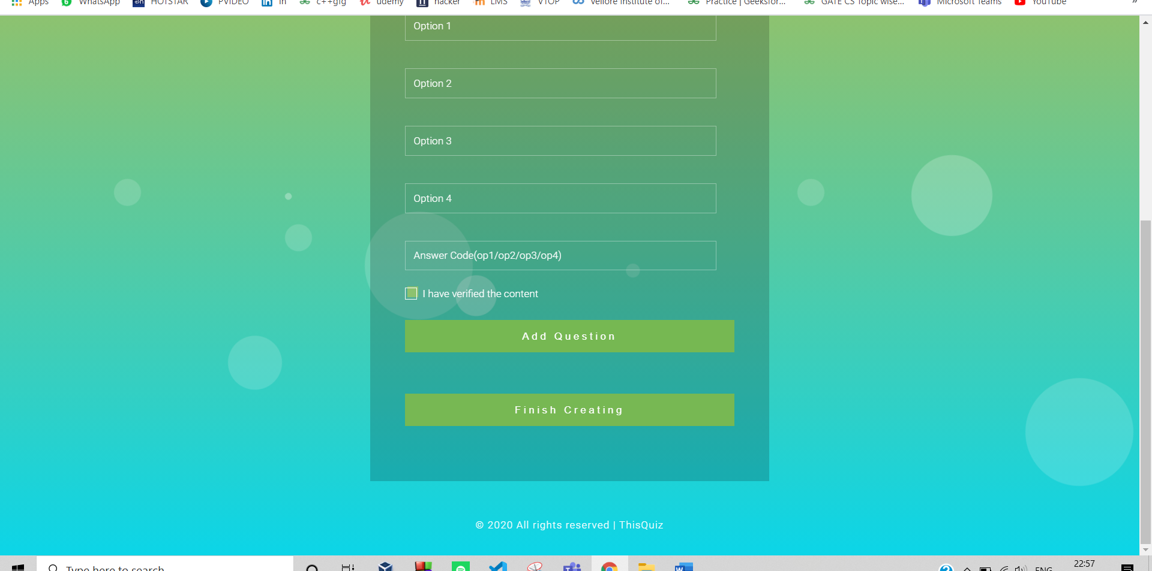

INSERTING THE QUESTIONS INTO THE QUIZ, WE TAKE CARE OF THE QUIZ CODE WHICH SHOULD BE SAME FOR EVERY QUIZ.

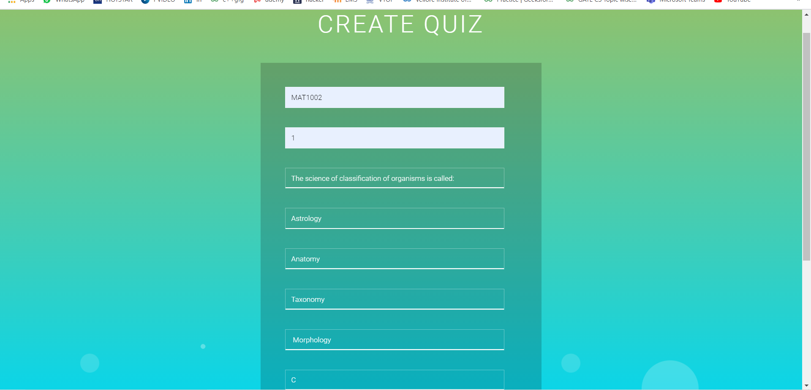

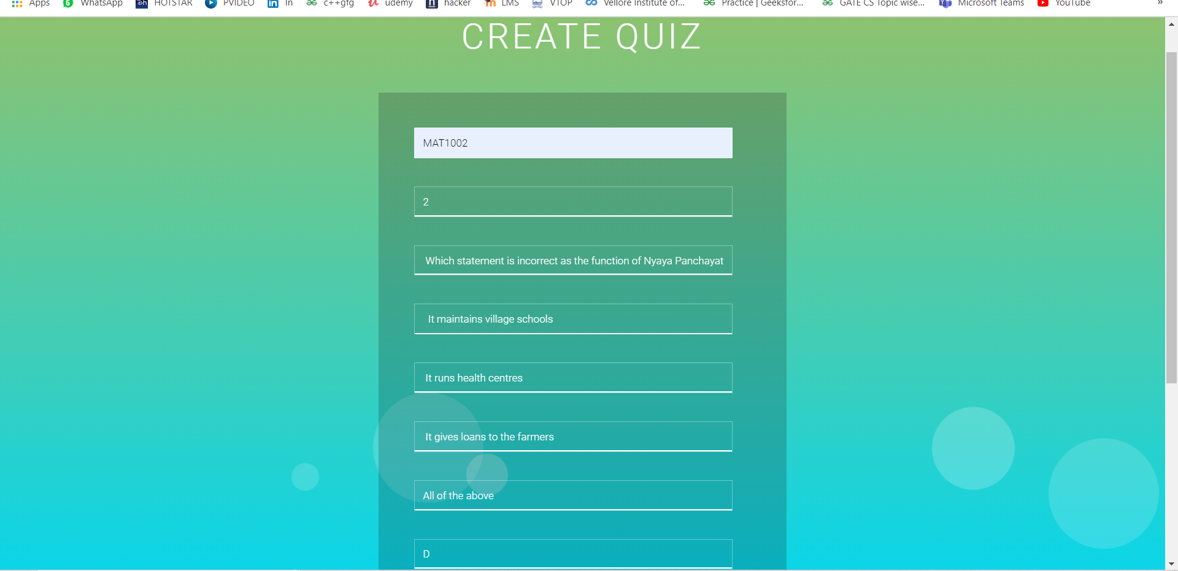



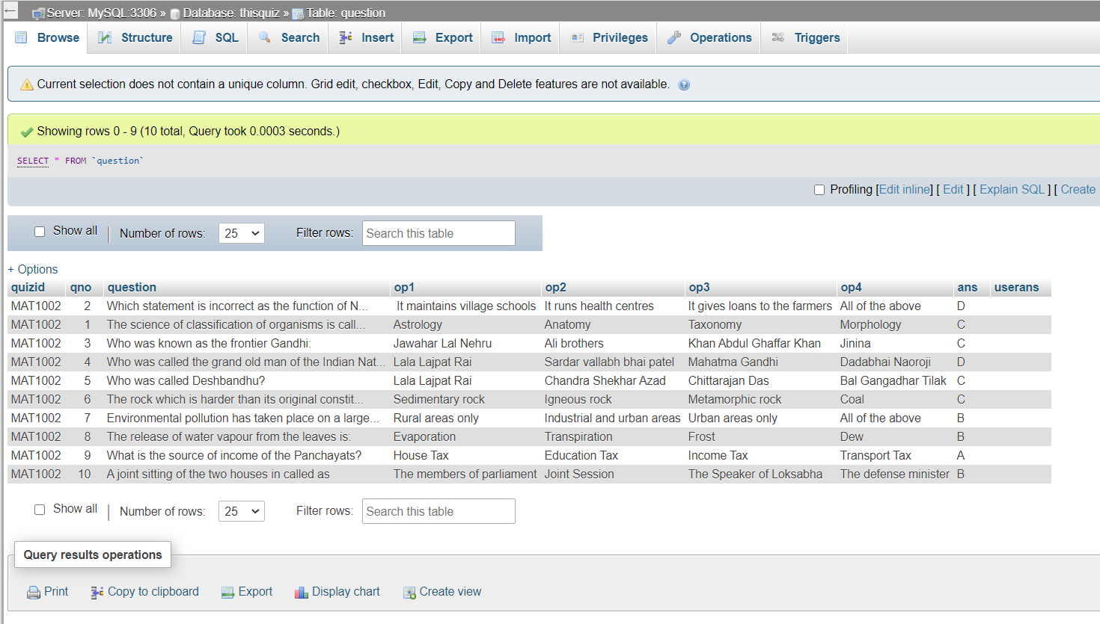

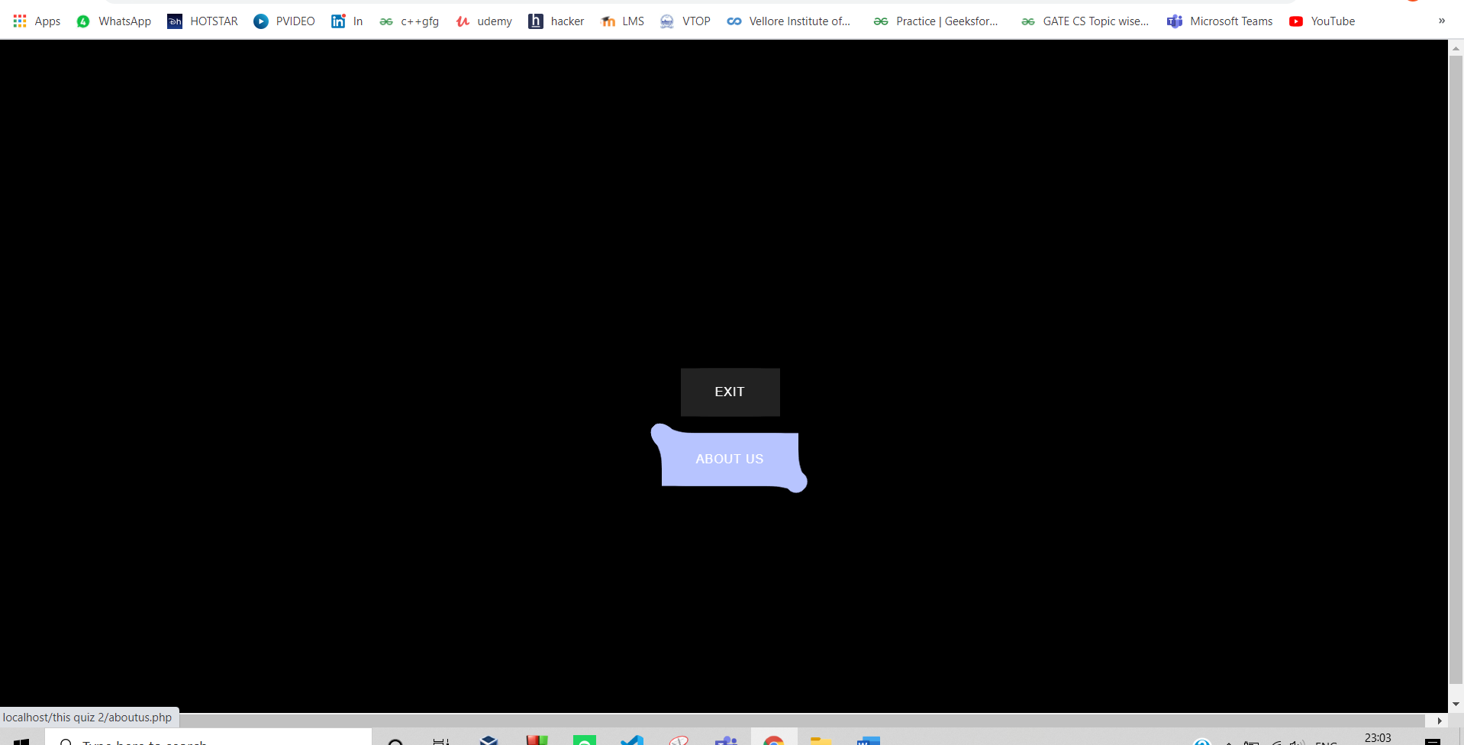

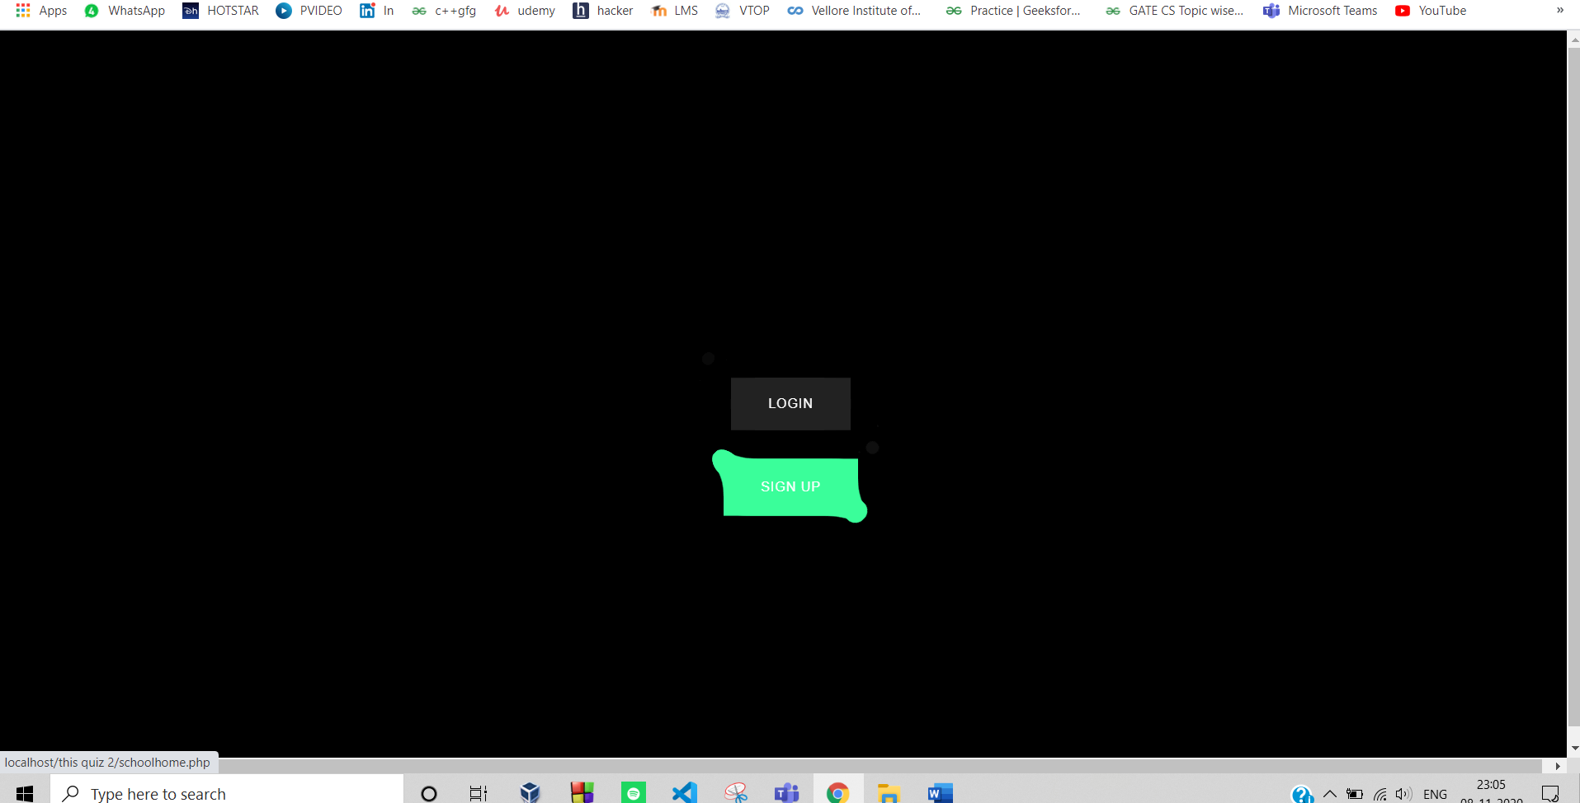

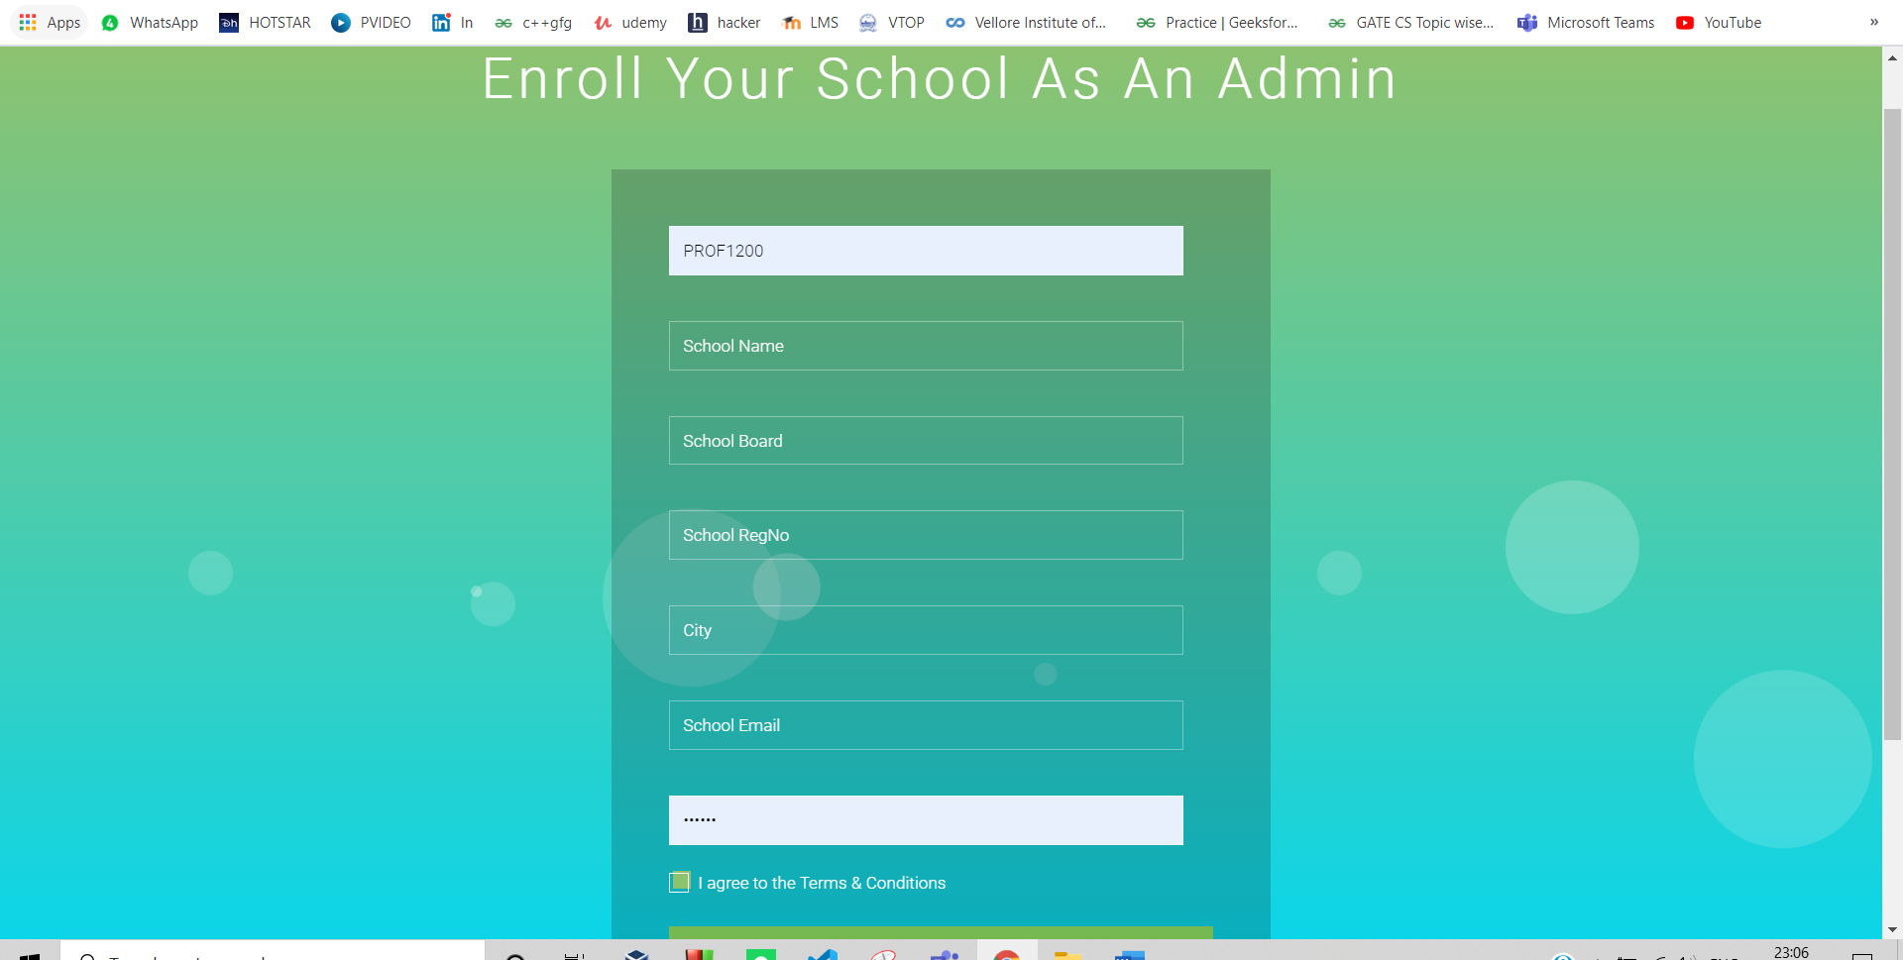

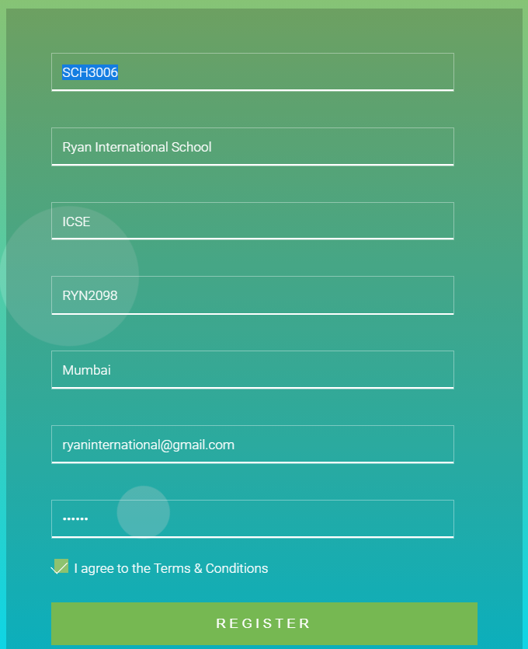

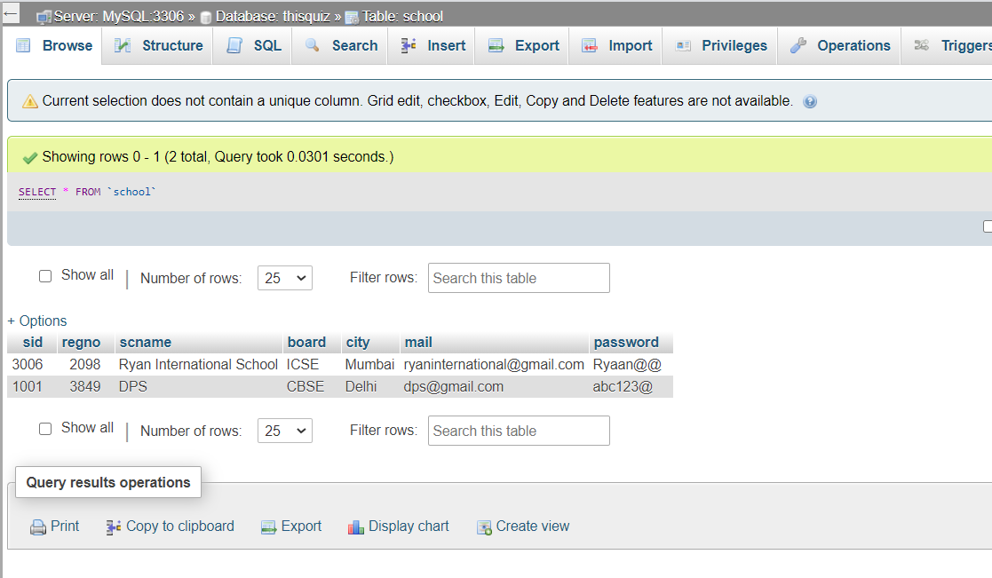

NAVIGATING TO THE INDEPENDENT USER



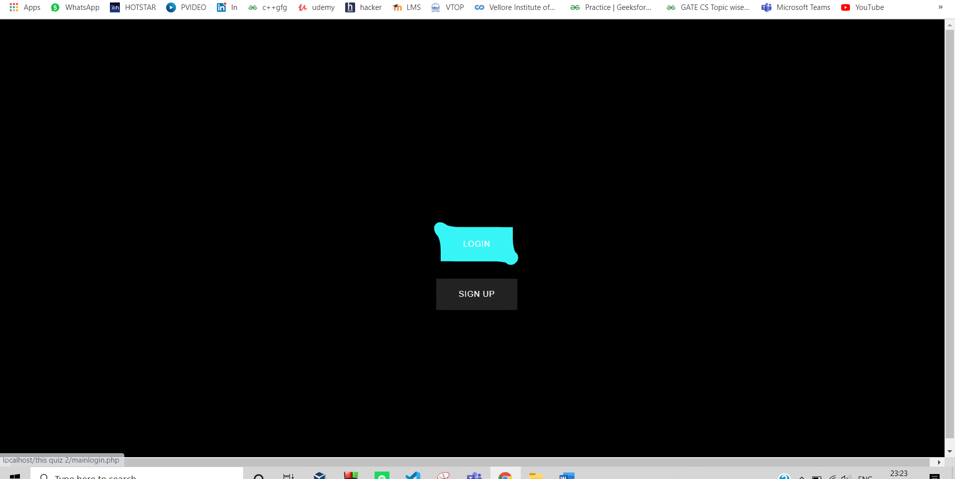

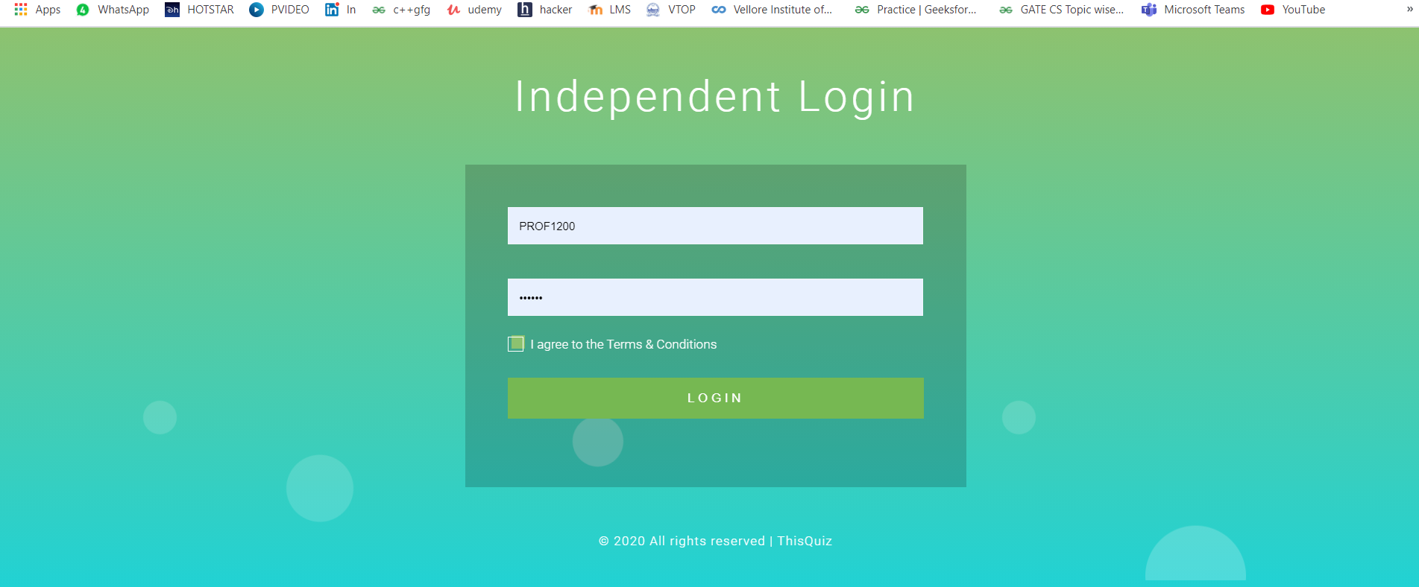



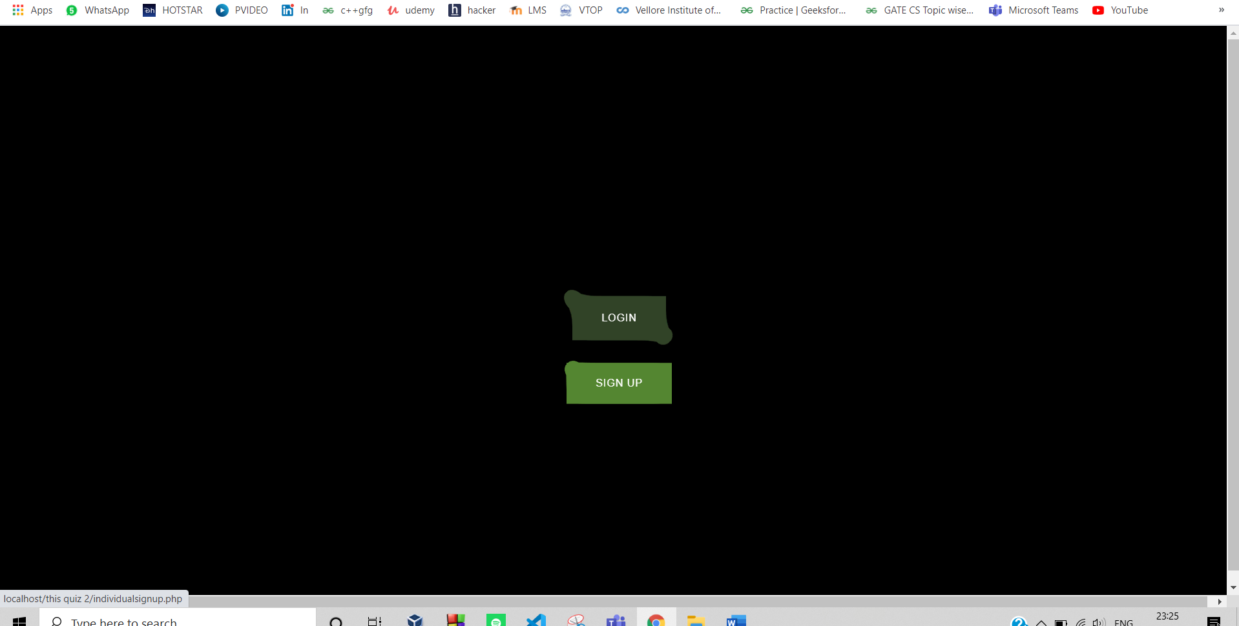

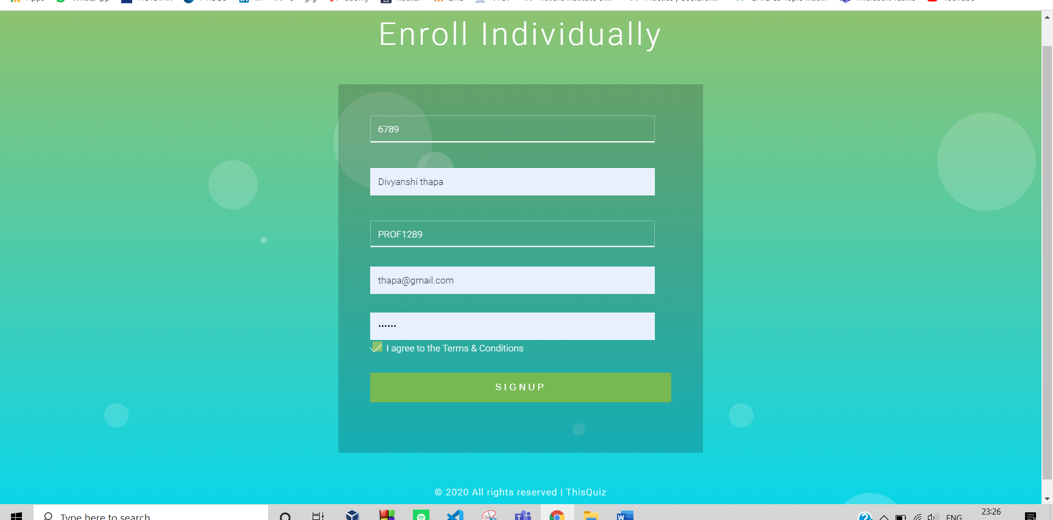

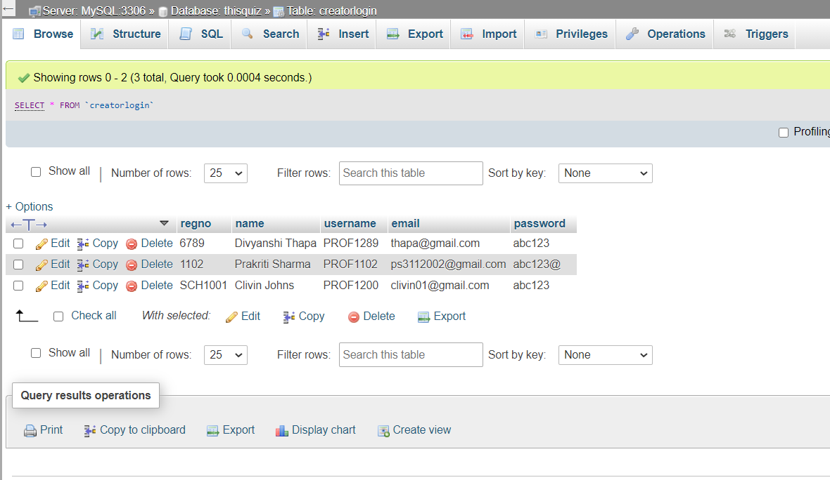

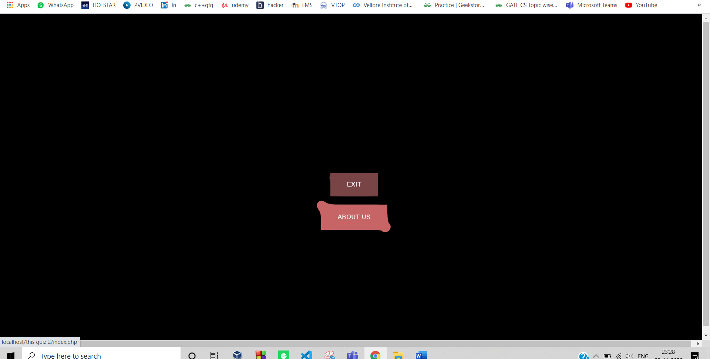

NAVIGATING TO THE “TAKE THE TEST” PANEL:



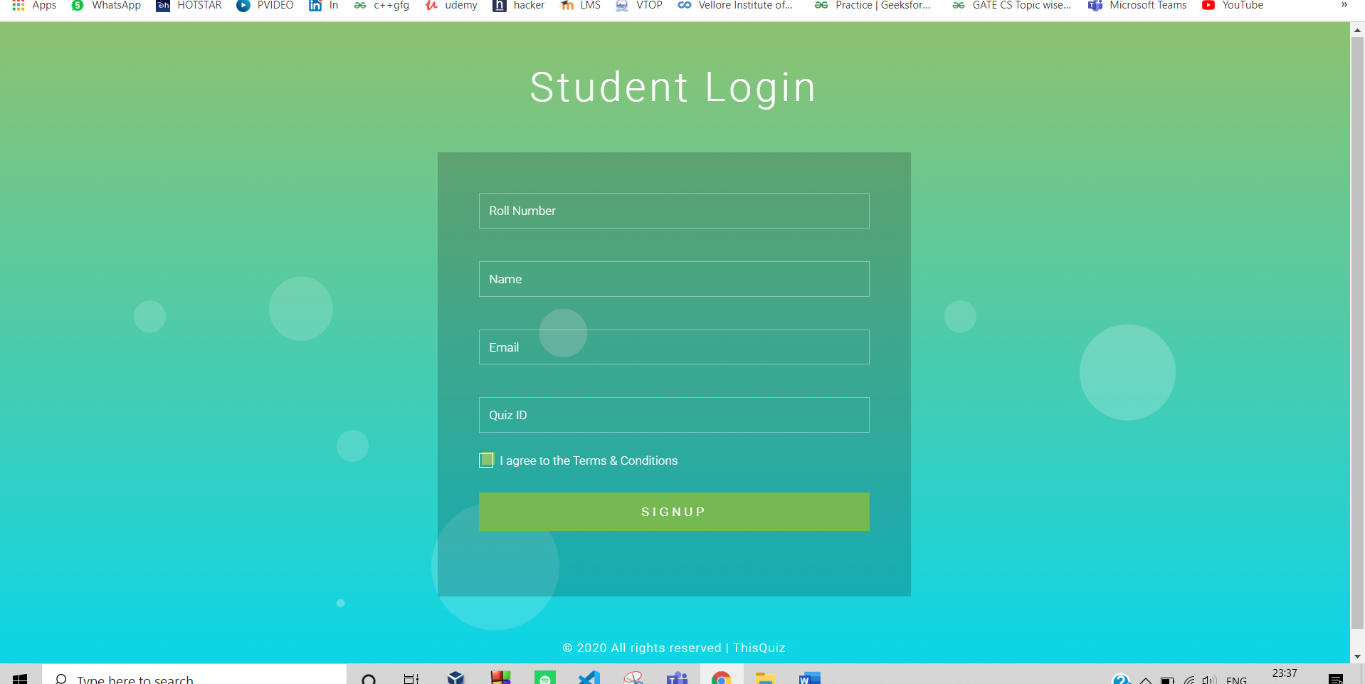

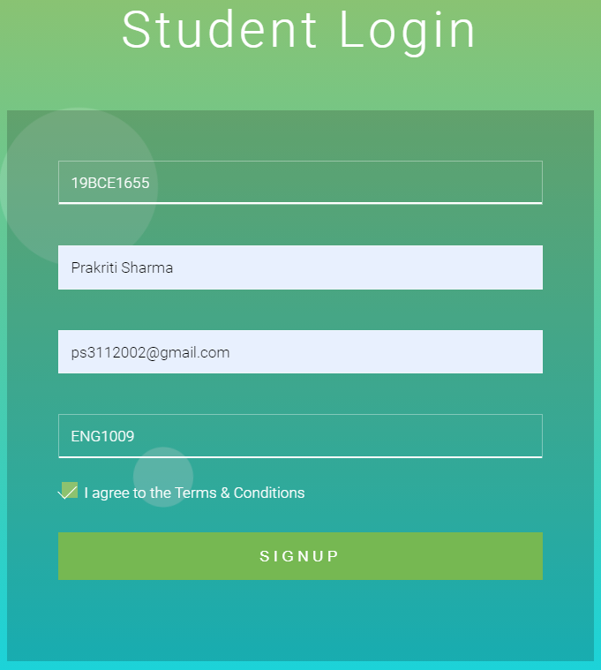

THIS IS THE SCREEN SHOT ON ONGOING QUIZ :



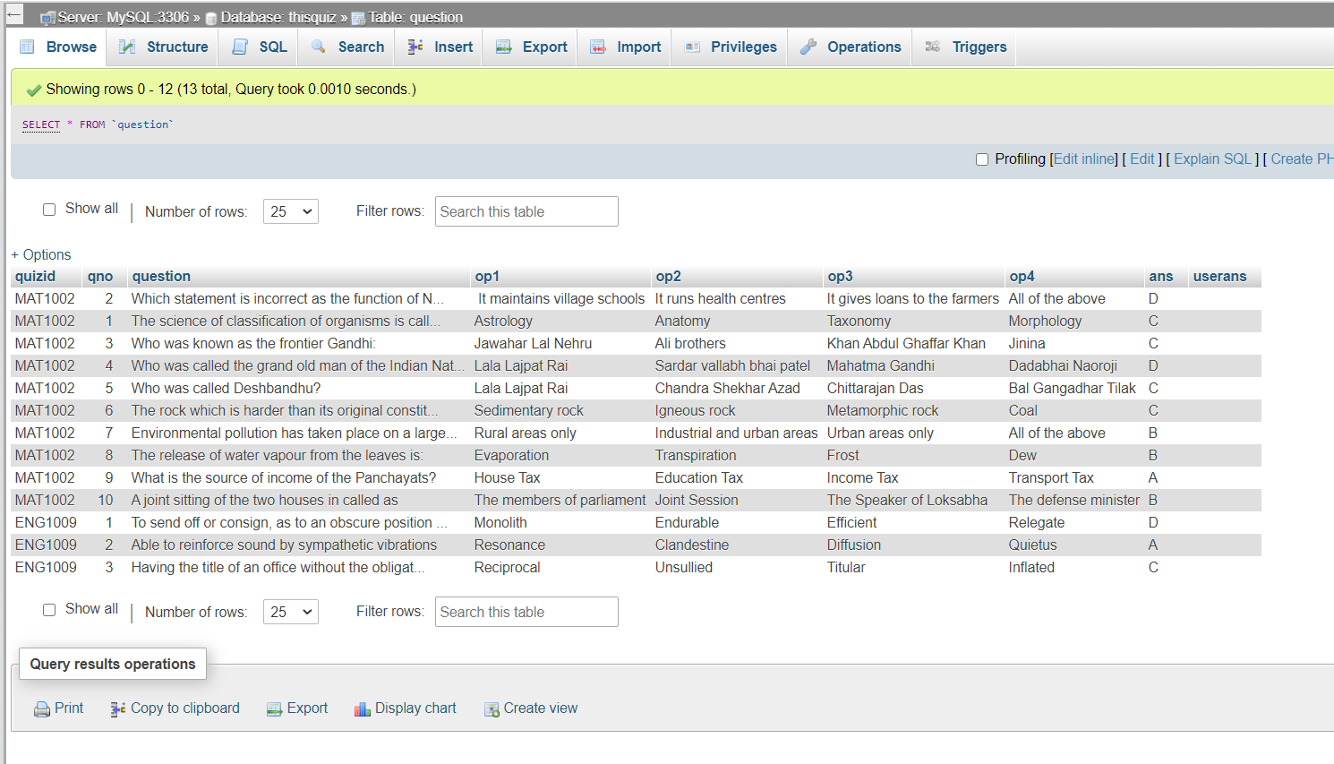

Quiz Results :



MAILED RESPONSES TO THE STUDENT :

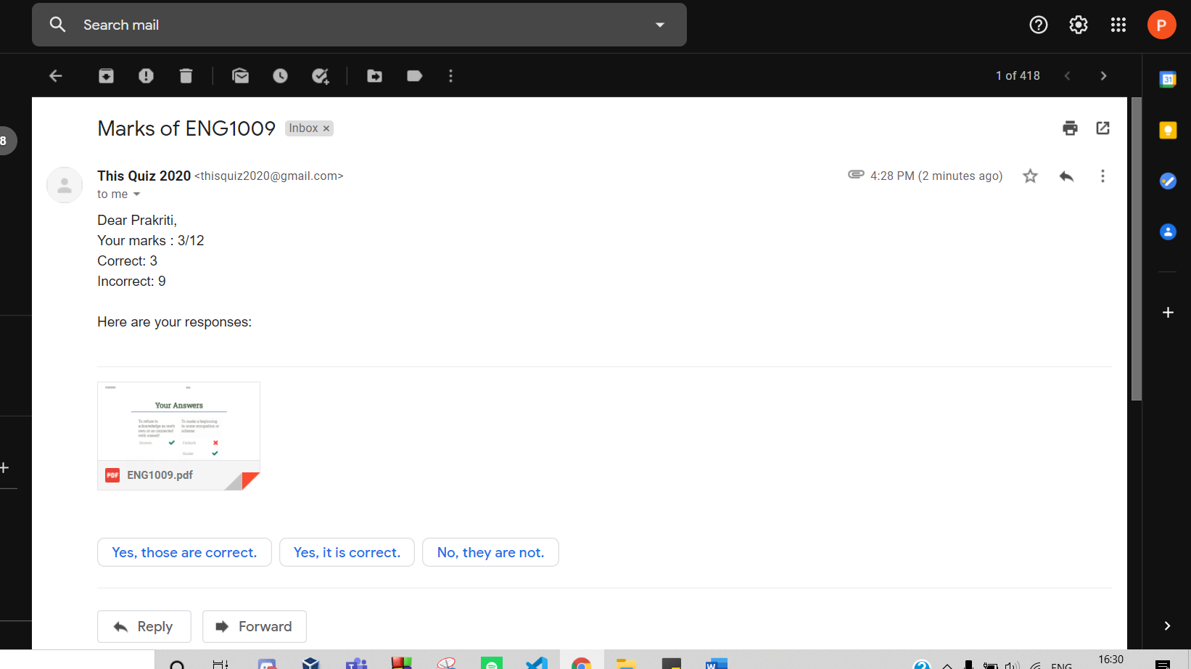

PDF of solutions :

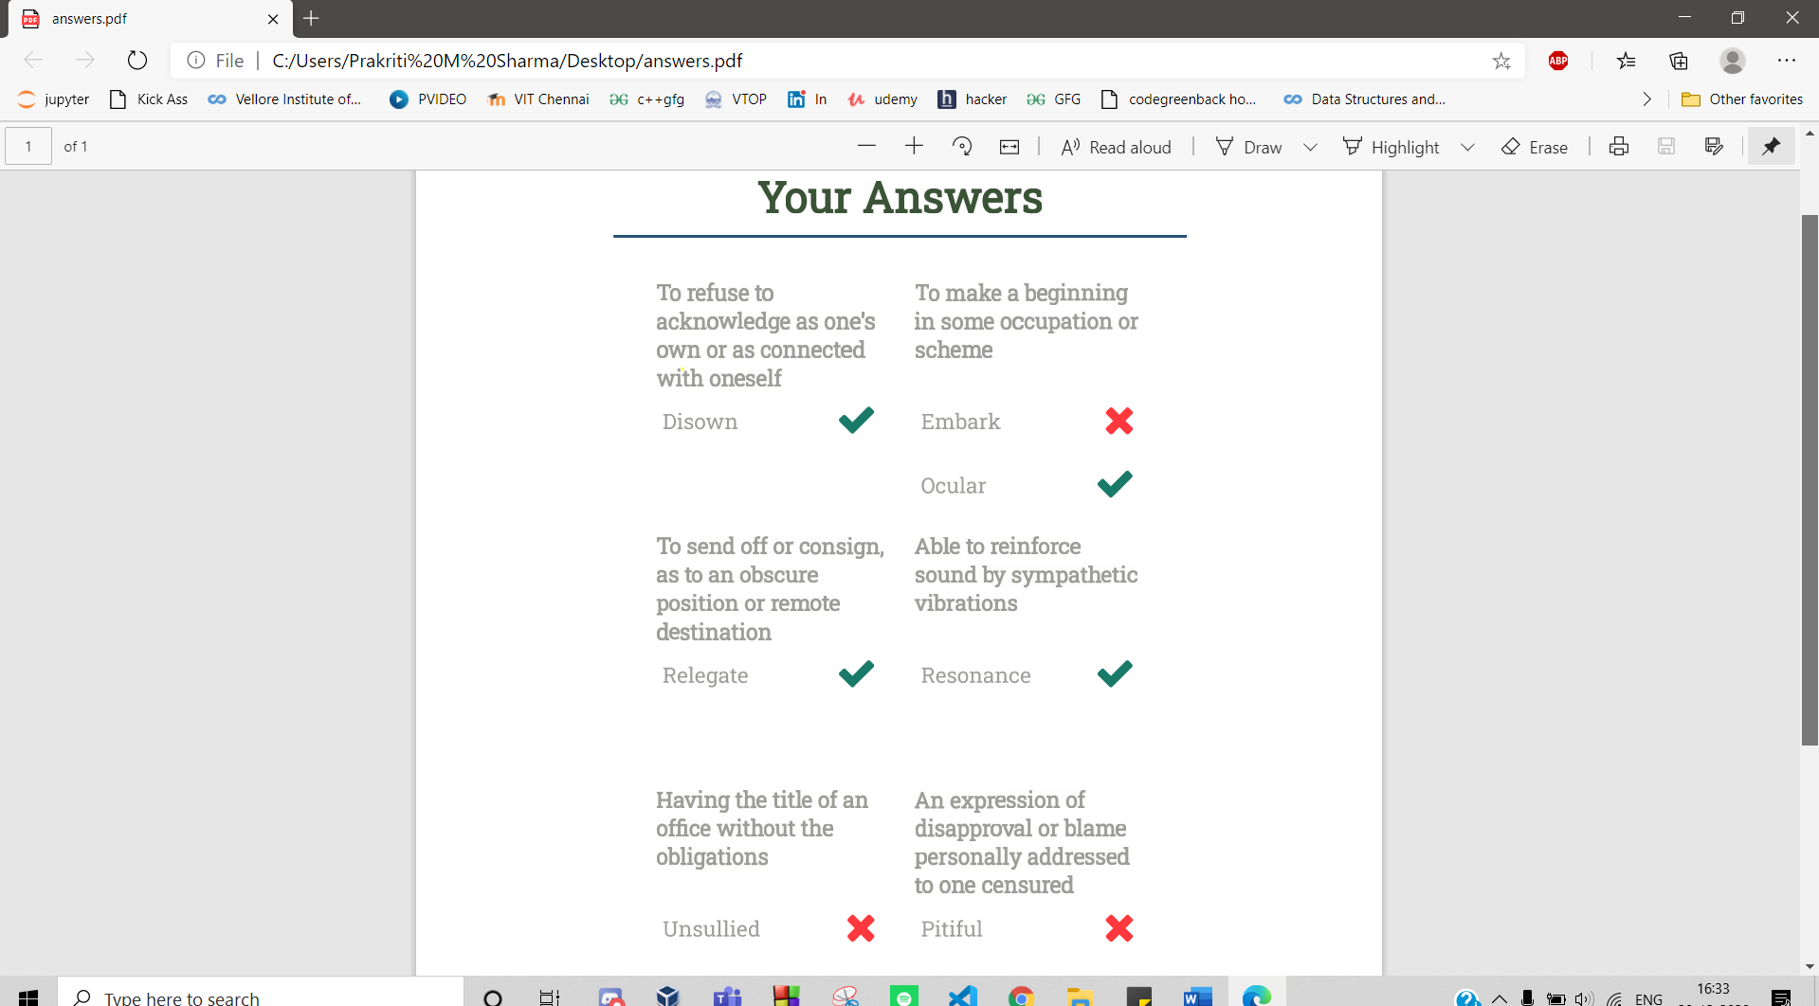



DATABASE

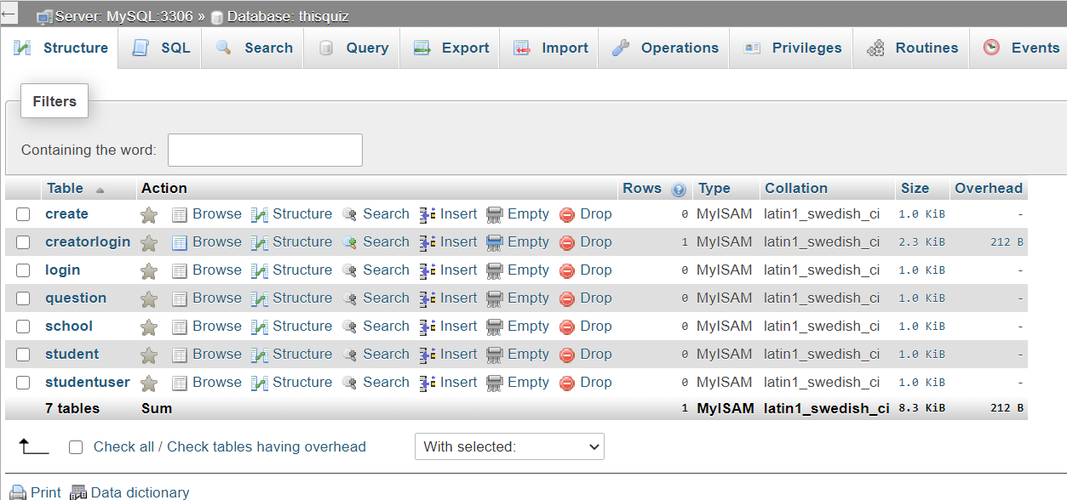

DATA BASE SCHEMA:

STRUCTURE OF EACH TABLE

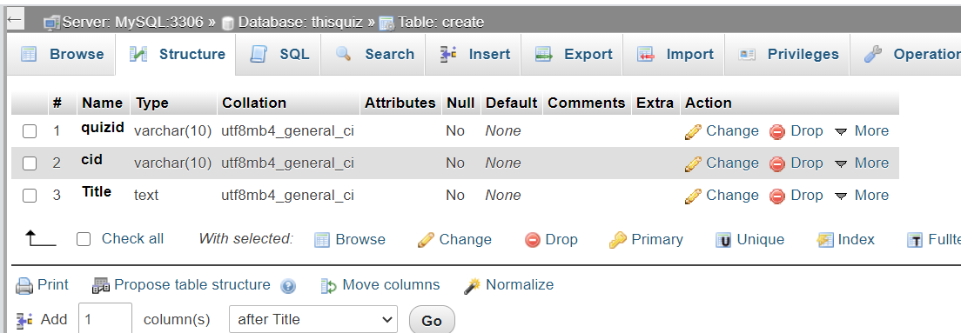

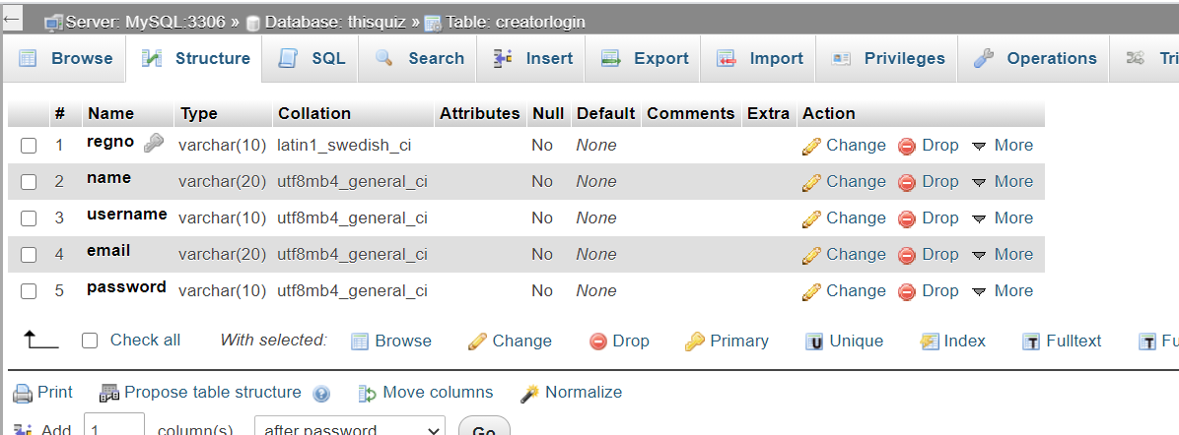

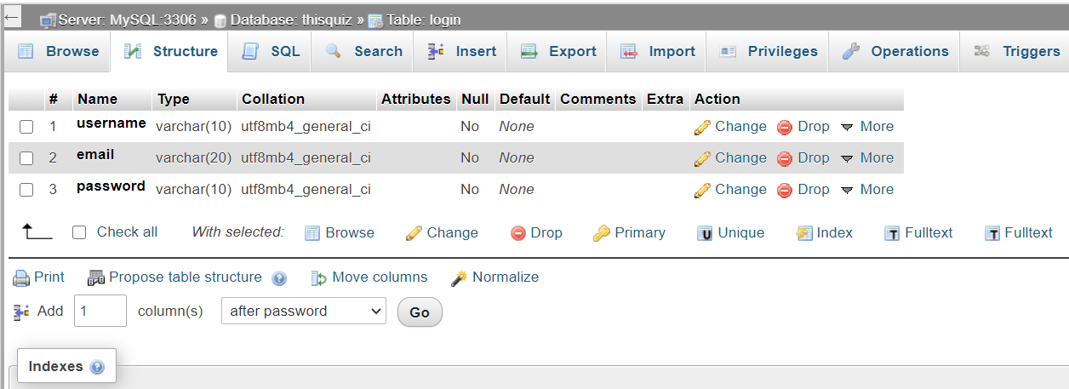

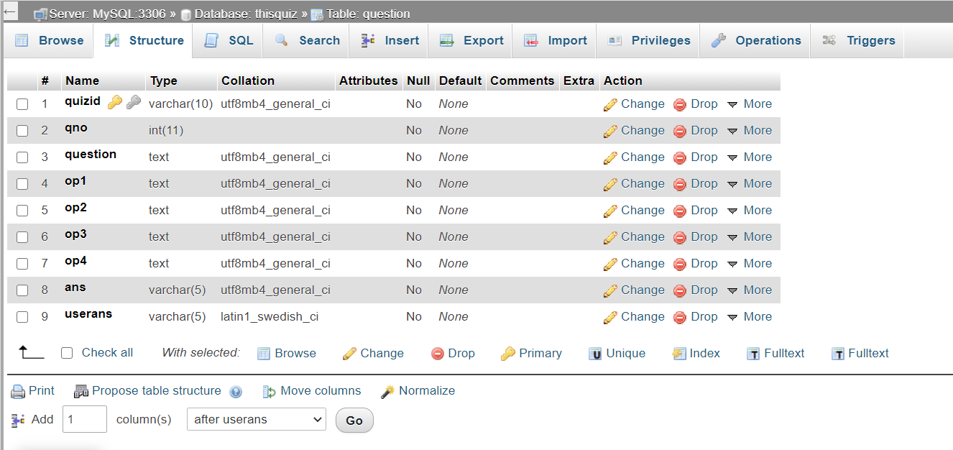

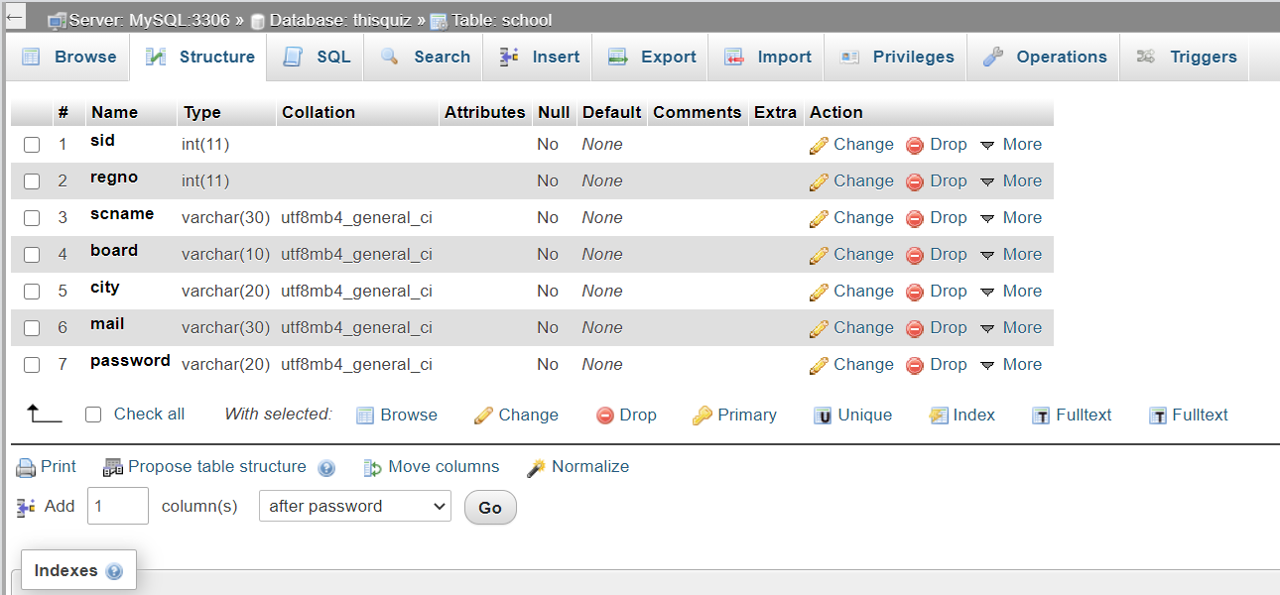

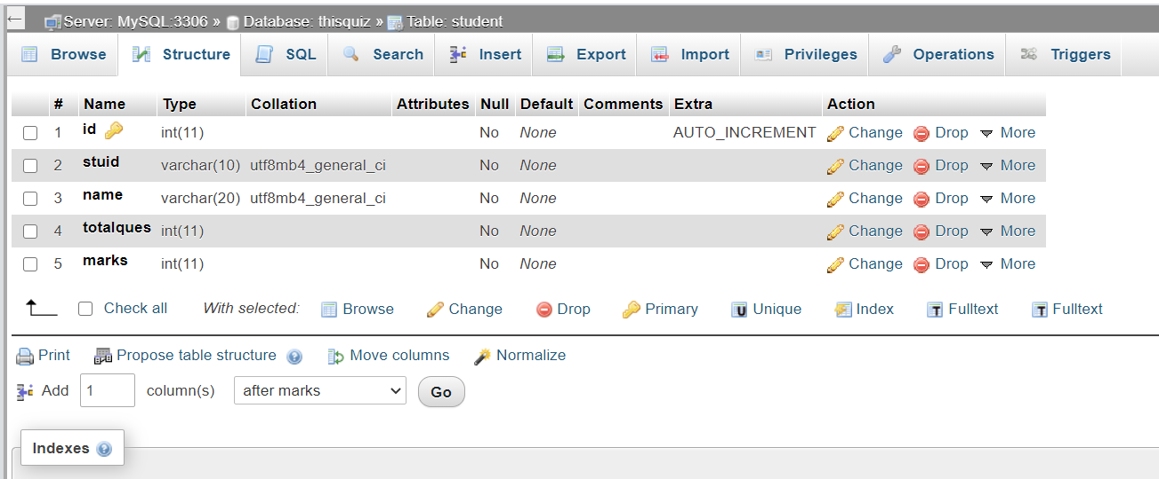

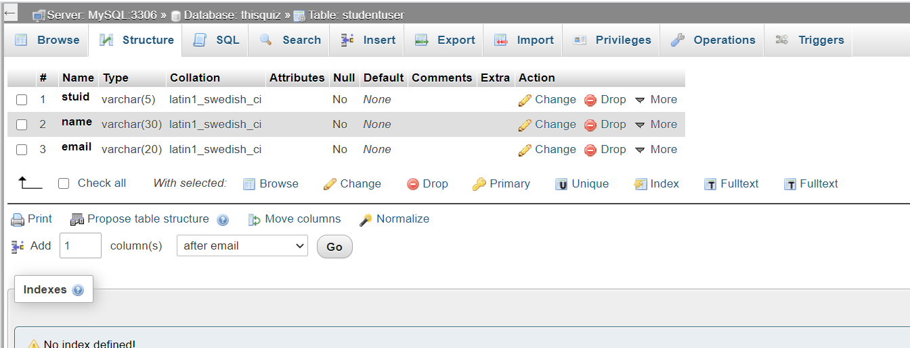

After entering questions into the database:



**CONCLUSION**

As a conclusion, the team has created a one stop solution for online quiz making everything easier for institutions, faculty members as well as students. This application provides each and everything an institution needs, for conducting online quiz.

This main aim for developing this platform was creating a user friendly interface for the schools so that everyone can create quiz easily and the assessment becomes easy.

While developing this platform, the teams explored various languages for development and worked them out to develop a platform which can be proved useful in these hard times of pandemic.